Oakland International Fellowship Paul J. Bucknell

Romans 1:1-7 Handout

A Sneak Preview

Purpose of the Book of Romans
God has specially designed goals for each Bible book to equip His people in significant areas of training (2 Tim 3:15-16). One way to summarize Romans’ purpose is: ‘Laying a solid foundation for the people of God.’ The force behind this book is the powerful way the gospel of Jesus Christ is presented, defended and applied so that God’s people, no matter what nationality, completely set themselves apart for God (Rom 12:1-2).
Romans: Chapters 1-11
“I urge you therefore, brethren, by the mercies of God, to present your bodies a living and holy sacrifice, acceptable to God, which is your spiritual service of worship. And do not be conformed to this world, but be transformed by the renewing of your mind, that you may prove what the will of God is, that which is good and acceptable and perfect” (Rom 12:1-2; NASB used unless noted).

“I felt my heart strangely warmed. I felt I did trust in Christ, Christ alone, for salvation; and an assurance was given me that He had taken away my sins, even mine, and saved me from the law of sin and death.” John Wesley 1738
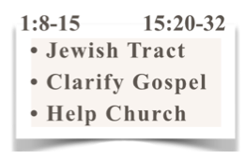
“For I am not ashamed of the gospel, for it is the power of God for salvation to everyone who believes, to the Jew first and also to the Greek. For in it the righteousness of God is revealed from faith to faith; as it is written, ‘BUT THE RIGHTEOUS man SHALL LIVE BY FAITH’” (Romans 1:16-17).

The Situation for the Book of Romans
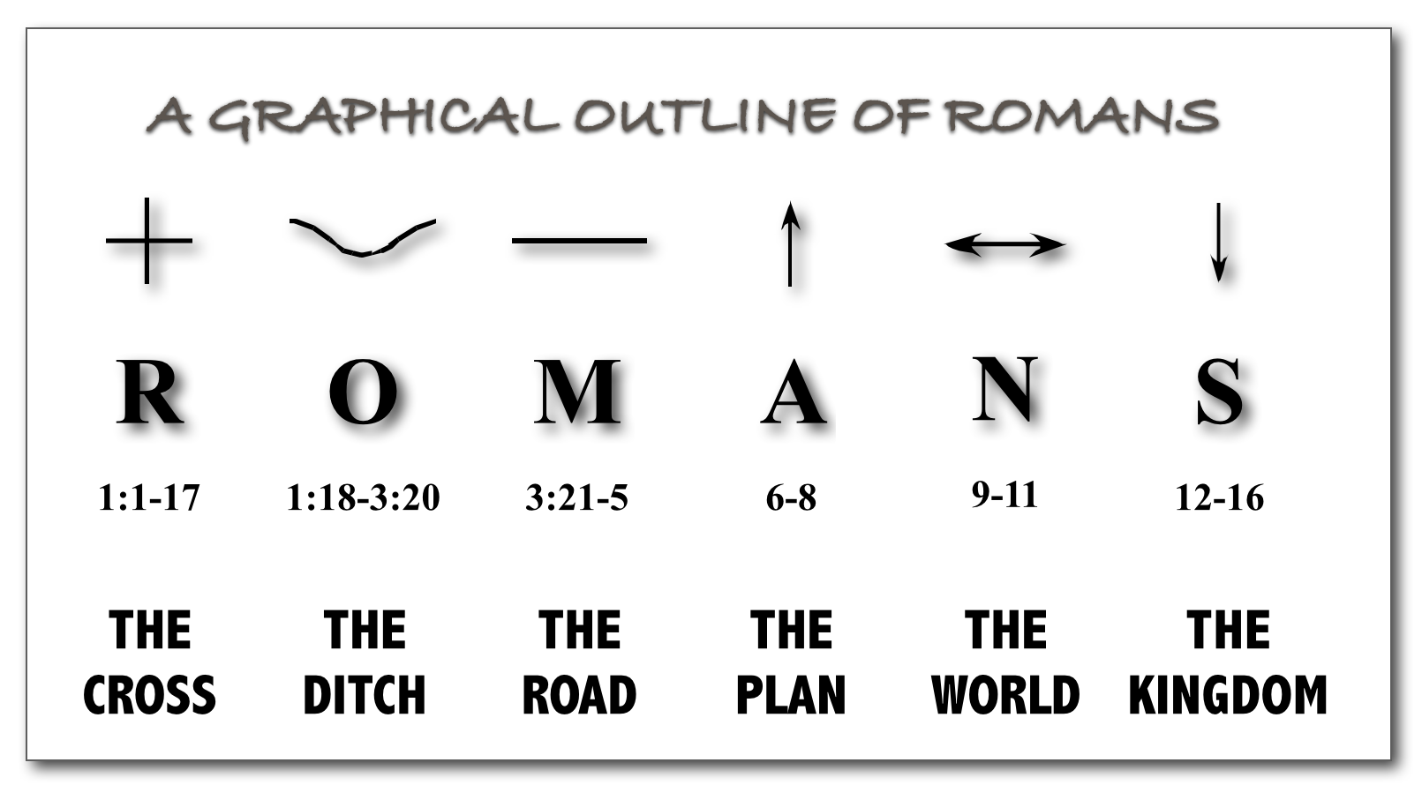
Rome, founded in 735 BC, back in Paul’s day had 1-4 million residents with over 400 temples to Roman gods and of those they conquered. A sizable colony of Jews lived in Rome. Rome is not identified as a church (contrast with 1 Cor 1:2; 1 Th 1:1) as it did not fully differentiate itself from the Jewish community, nor had the apostles visited Rome to organize the church or provide a solid foundation for their beliefs. Furthermore, persecution against Roman believers had and would again arise against the Jews/Christians (persecution returned in 30 AD and again after Claudius’ death in 54). The Book of Romans provides that crucial Jewish-Gentile Christian perspective so that they can work as one church. Paul also announced his plans for a fourth trip to Rome and a missionary trip to the far West (1:8-15; 15:20-32). Paul wrote Romans in Corinth after he wrote 1 & 2 Corinthians (15:26; 16:1).

The Outline of the Book of Romans
A. Righteousness Revealed__: Gospel (1:1-17)
B. Righteousness O________: Sin (1:18-3:20)
C. Righteousness M_______: Justification (3:21-5:21)
D. Righteousness A________: Sanctification (6-8)
E. Righteousness eNlarged__: Worldwide (9-11)
F. Righteousness Spread____: Service (12-16)

The Gospel’s Message ( Romans 1:1-7)
The powerful gospel message and its implications for our lives is presented in Romans 1:1-7.
- Romans 1:1-7 answers the question, “What is the Gospel?”
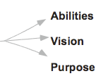
- God’s righteousness is shown through the glorious Gospel of Jesus Christ. (1:1,9,15,16)

The Proclaimer of the Gospel (Romans 1:1)
¹Paul, a bond-servant of Christ Jesus, called as an apostle, set apart for the gospel of God.
- Paul the slave of Christ Jesus
- Called as an apostle
- Purposed: “Set apart for the gospel of God.”

2. The Promise of the Gospel (Romans 1:2)
²Which he promised beforehand through his prophets in the Holy Scriptures.
- “Beforehand” – Purposed rather than accidental
- “Through His prophets” – Recorded in the ancient holy Scriptures (Note his respect for scriptures)
- “Promised” – God’s commitment to rescue and restore mankind

3. The Person of the Gospel (Romans 1:3-5)
³Concerning his son, who was born of the seed of David according to the flesh, ⁴who was declared with power to be the Son of God by the resurrection from the dead according to the Spirit of holiness, Jesus Christ our Lord, ⁵through whom we have received grace and apostleship to bring about the obedience of faith among all the Gentiles, for His name’s sake.
Note Romans 12 where Paul clearly sees each believer a member of Christ’s body and each having a spiritual gift and responsibility for the body of Christ and the lost.
- Gospel is all about Jesus – “His son” is God’s son. (What are false gospels then?)
- Jesus’ earthly _________ – “born”. God became man (Phil 2:3-11).
- Jesus’ _______ – “from the dead”. Paul emphasizes the purpose of His death in Romans.
- Jesus’ _________________. Proof of Jesus’ righteousness; also emphasis in Romans
- Jesus’ ________ – “Jesus Christ our Lord”. Not dead but living and leading, expecting our allegiance
- Jesus’ grace and gifts – “received grace…”. Christians’ call: received, envisioned, passionate
- Jesus’ mission – “to bring”. He employs us to join Him to “bring about the obedience of faith” for His glory.

4. The People of the Gospel (Romans 1:6-7)
⁶Among whom you also are the called of Jesus Christ; ⁷to all who are beloved of God in Rome, called as saints: Grace to you and peace from God our Father and the Lord Jesus Christ.
- Review 1:3-5. Jesus’ work and purpose changes our relationship to Him. Key words: discipleship, follow, obey, proclaim,…
- Participation in the calling (6-7a) We => you
- Indian restaurant owner example
- Partakers of the benefits (7b)
    - Grace is the favor God bestows on us unworthy creatures enabling us to know and obey Him.
    - Peace is the calmness within our hearts and minds that governs our lives in a tumultuous world.

Summary
The gospel, like an intriguing entry way, brings us into an amazing place (our life) where we find ourselves living a different life: specially outfitted, conscious of a superior commander, and living with new orders. Jesus is alive working powerfully in our lives along as well as other genuine believers of God, the church.

Discussion questions:
- What truth about Christian faith or life do you wrestle with most?
- Do you see yourself as God’s specially gifted servant carrying out God’s greater purposes? Explain.
- What has God called you for? How has He specially gifted you for this purpose? What are you doing about it?

