Observing the Flow
Lesson 1, Exercise #1

Purpose
As we clearly identify and connect God’s work to our own spiritual lives, our confidence in God’s work grows and reminds us of the Lord’s purposed involvement in our lives.

Directions
Just as physical life demonstrates its presence–such as in breathing, spiritual lives also manifest their presence.
- List at least six signs of spiritual life that should be true of all genuine believers.
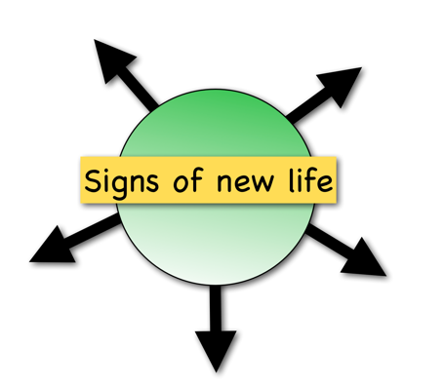
- Double check and make sure your listed signs are not simply outward religious behaviors.
- Place a checkmark next to those that are true of your life.

Conclusion
These signs of our spiritual life are expressions of how God is working in our lives, transforming us to be like Jesus! Our excitement of what God is doing in our lives is often linked to how much we see ourselves growing as a follower of Christ. Recognize that the Lord is alive and working in you. Give thanks and rejoice that the Almighty God gets so involved in your lives.

Observing the Flow
Lesson 1, Exercise #1 Completed

Purpose
As we clearly identify and connect God’s work to our own spiritual lives, our confidence in God’s work grows and reminds us of the Lord’s purposed involvement in our lives.

Directions
Just as physical life demonstrates its presence–such as in breathing, spiritual lives also manifest their presence.
- List at least six signs of spiritual life that should be true of all genuine believers.
- Double check and make sure your listed signs are not simply outward religious behaviors.
- Place a checkmark next to those that are true of your life.

- I sense God’s power in my life.
- Before I was saved, I was quite content to focus on my own needs.
- God actually stirs me to practically love others.
- I always had a slight conscience but now am very alert to sin’s presence.
- God’s Word has all of a sudden leaped in importance to my life.
- I used to focus on what I wanted but now try to see what God has for my life.
- Worship used to mean religious attendance but now I love God!
- I used to give because I cared what people thought of me, but now I give because I want to.
- Fellowship with others is important to me because we are meant to grow together.
- Prayer is no longer a religious ritual but real time talking to God.

Conclusion
These signs of our spiritual life are expressions of how God is working in our lives, transforming us to be like Jesus! Our excitement of what God is doing in our lives is often linked to how much we see ourselves growing as a follower of Christ. Recognize that the Lord is alive and working in you. Give thanks and rejoice that the Almighty God gets so involved in your lives.

Catching God’s Vision for Me
Lesson 1, Exercise #2

Purpose
Just like a seed, our faith in Christ is designed to grow into a ‘tall’ faith for His glory. What does that design look like for you in your Christian faith? What does a Christian look like all grown up?

Directions
Finish this statement with at least three general or specific personal goals God has for you.

Because God has invested His spiritual life in me, He wants me to:
- ___________________________________________________________________________
____________________________________________________________________________
- ___________________________________________________________________________
____________________________________________________________________________
- ___________________________________________________________________________
____________________________________________________________________________
“Not that I have already obtained it or have already become perfect, but I press on so that I may lay hold of that for which also I was laid hold of by Christ Jesus.” (Philippians 3:12 NASB)

