Oakland International Fellowship Paul J. Bucknell

Fathers ~ Strengthening Faith
(1 John 2:12-14)
Session #9
A biblical exposition of 1 John 2:13-14 lays bare the goal for every believer to become a mature believer, deepening that relationship with God by further grasping God’s holy and eternal person so that they, being thoroughly enriched, can join the Lord in effectively serving others.

Spiritual Growth Questions
  - What is the design that God has for each believer?
  - How does God lead us into deeper intimacy?
  - How does serving fit into God’s overall purpose for our lives?
  - Do we ever stop growing?

Observation of Order from 1 John 2:12-14
- What order are the three groups presented? ________________________ Why?
- Focus
- Have you thought out what maturity means for you as a believer?
‘Father’ summarizes the believer’s purpose, goal, and design.

Stage #3 Discoveries from 1 John 2:12-14 - “I am writing to you, fathers”
  - Path of Discipleship > Stages #1, 2, 3
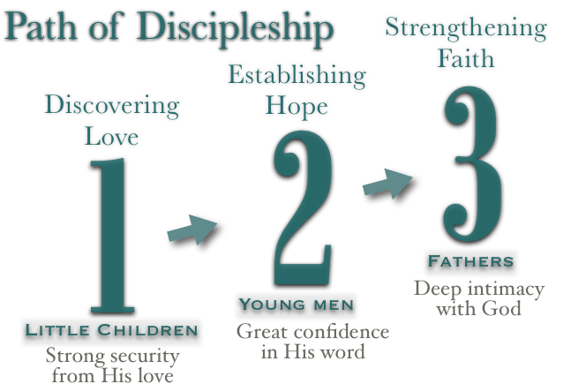
  - Spiritual growth follows an increase of faith
  - The mature have a ‘seasoned’ faith
  - “Not that I have already obtained it, or have already become perfect, but I press on in order that I may lay hold of that for which also I was laid hold of by Christ Jesus” (Philippians 3:12).
- 3 Lessons

#1 Strengthening of Faith - ________________
  - What makes a father a father?
  - Sisters are also considered as ‘fathers’.
“Older women likewise are ... to encourage the young women to love their husbands, to love their children, to be sensible, pure, workers at home, kind, being subject to their own husbands, that the word of God may not be dishonored” (Titus 2:3-5).
  - Need: Focus on producing and caring for ________________ children.

#2 Strengthening of Faith - ________________
  - “Know Him” - relating to Him
  - Abiding deeply in the Lord: “But whoever drinks of the water that I shall give him shall never thirst; but the water that I shall give him shall become in him a well of water springing up to eternal life” (John 4:14).
  - Need: Focus on relationship building

#3 Strengthening of Faith - ________________
  - “Know Him” - know Him on a deeper personal level
  - The Lord’s greatness: “For from Him and through Him and to Him are all things. To Him be the glory forever. Amen” (Romans 11:36).
  - Need: Persistent pursuit to deepen our knowledge of the Lord.

Train mature believers how to:
- Seek intimacy with God (John 15:5)
- Dive deeper in His Word
- Wrestle through deep personal struggles
- Persevere when others have given up
- Believe when others doubt
- Be pure in an impure society
- Demonstrate God’s love through serving others
- Kindly confront others as needed
- Keep your first love on the Lord
- Manage your time well; don’t neglect any responsibility

Discipleship Level 3: Strengthening Faith
'Fathers' become more intimately acquainted with God through trying experiences and a deepening trust in Him, purposely investing their lives to help others grow in Christ. Intimacy with God the Father produces glorious results as we better discern and complete the Lord’s good works. God further reveals His mysterious self, welcomes us step further in, and engages us to carry out His good works.
- Every believer is designed to grow into a strong believer who serves others.
- Spiritual growth can always deepen our increasing faith in God’s glorious person and ways. No matter which situation I find myself in, God will bear fruit that glorifies Him.
- The believer’s intimacy with God is often developed through trying circumstances.

Discussion Questions
- Are you still growing as you should in your relationship with God? Explain.
- What is one Christian spiritual discipline that helps shape your life?
- Give an example where you have encouraged another person so that they actively helped others.

