Oakland International Fellowship Paul J. Bucknell

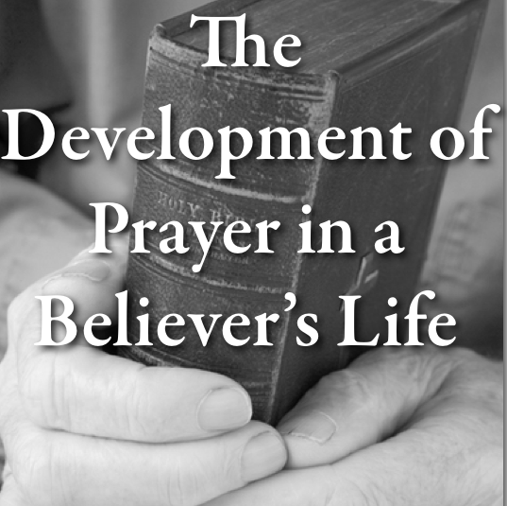
Growing in Prayer (Eph 6:18)
Session #17
Every relationship is founded on good back and forth ____________, and so prayer becomes the key means the Christian develops his/her relationship with God. Our spiritual conversation (i.e. prayer) develops as we grow in our spiritual lives.
“With all prayer and petition pray at all times in the Spirit, and with this in view, be on the alert with all perseverance and petition for all the saints” (Eph 6:18).
- The New Believer - the little child (Level #1)
Don’t we all love to see how babies learn to talk? No one complains that their words are not rightly formed. If they ask amiss, we smile and offer them what is good and safe (Mat 7:10). Think what happens when a new believer comes to know the Lord and begins talking to God. The Father is so excited at His child’s first words.

Affirm faith

Spiritual Network
“Even so the thoughts of God no one knows except the Spirit of God. Now we have received, not the spirit of the world, but the Spirit who is from God, that we might know the things freely given to us by God” (1Cor 2:11-12).
New believers begin to _______ to God. Every word spoken to God (i.e. prayer) is an affirmation of their faith.
=> Does your Heavenly Father delight in hearing from you?

Confess sins
The way believers prayerfully handle their sin greatly affects their spiritual lives.
=> Do you wrestle with confessing your sin?

Seek to please God
The Spirit of God begins to prod us to and not to do certain things.
=> Do you question whether God’s will for your life is always best for you? In what areas?

Thank the Father
“In everything give _______; for this is God’s will for you in Christ Jesus” (1 Thessalonians 5:18).
=> Do you use prayer to express your growing admiration of the Father’s care for you?

Trust Father (Protect, guide, provide, comfort)
The believer is learning to live in God’s presence, even recognizing His presence. This trust develops through simple prayers during our conversations with God, some silently in their minds while others quite vocal.
Summary: By discovering God’s love, new believers grow confident in His care for them.
- The Young Believer - the Teen (Level #2)
By seeing the power of God’s Word at work in my life, my faith is ____________, and my hope in God’s work in my life is strengthened.

Being an Overcomer
Prayer brings us to God, starting with a humble prayer, proclaiming His truth, and building up our faith.
During prayer, we exercise our ________ of faith to bring clarity to our confused minds, “Taking up the shield of faith with which you will be able to extinguish all the flaming missiles of the evil one” (Eph 6:16).

Power of God’s Word (“because the Word of God abides in you” –1 John 2:14)
God’s Word is the driving force in prayer providing faith as we bring our requests and praise to God.
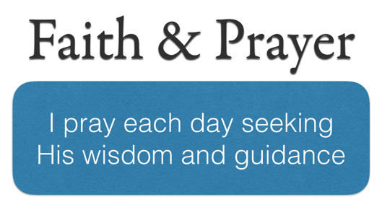
  - Promises (2 Peter 1:4): “He has granted to us His precious and magnificent promises.”
  - Abraham (Gen 15:8): “And he said, ‘O Lord GOD, how may I know that I shall possess it?’”
  - Exposes lies (Eph 5:13): “But all things become visible when they are exposed by the light, for everything that becomes visible is light.”
- The Mature Believer - the Father (Level #3)
By my growing faith, I can know God and trust him even in difficult times. He takes me ________ and closer to Him so that He can bear more fruit through my life to glorify Him.
  - The two previous stages are temporary while this stage does not ever end on earth.

Abiding in Christ
“Abide in Me, and I in you. As the branch cannot bear fruit of itself, unless it abides
in the vine, so neither can you, unless you abide in Me” (John 15:4).
  - Abiding prayer
  - Searching for what I can do to please the Lord.
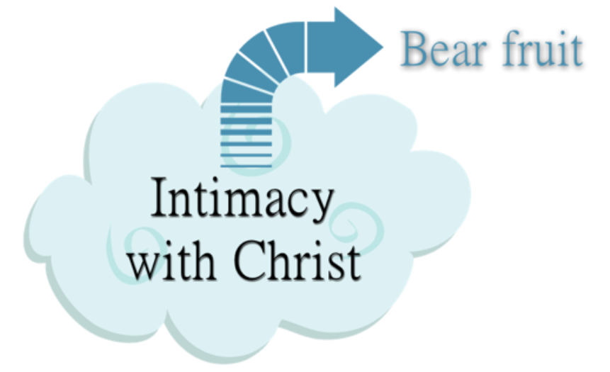
  - Prayer is an intimacy that bears fruit. Fruit comes from intimacy with the Lord.

Admire & Adore
  - Adoration occurs at all stages but constantly matures.
  - e.g., Psalms: “Blessed be the LORD, my rock, who trains my hands for war…” (Psalms 144:1).

Devoted despite trials
“The enemy has persecuted my soul; He has crushed my life to the ground; He has made me dwell in dark places, like those who have long been dead. Therefore my spirit is overwhelmed within me” (Ps 143:3-4).
  - We share our difficulties with God. “I trust in Thee, Teach me the way in which I should walk” (Ps 143:8).
  - We are not allowed to wallow in self-pity but are commanded to grow in our faith.

Pray for Others
“And pray on my behalf, that utterance may be given to me in the opening of my mouth, to make known with boldness the mystery of the gospel” (Ephesians 6:19).
  - We need prayer support from others.
  - Tests of our faith: What is it that we really want? How much do we want it?

Summary of Prayer Development
  - Our prayer lives grow as we grow in the Lord.
  - Our prayers are naturally affected by our growing faith.
  - God desires for us to commune with Him and for Him to work through our lives.

Discussion Questions
- What is your biggest struggle or greatest delight in prayer?
- What is an area of prayer than you want to learn more about or grow in?

