Oakland International Fellowship Paul J. Bucknell

Growing in Discernment (Eph 6:12)
Session #18
Spiritual discernment is the God-given ability to observe and understand the spiritual realm along with one’s own life and surroundings (John 3:3). The Spirit of God works in all new believers (Acts 1:8) bringing a whole new ability to relate to God and observe the dark and light forces around them. At each stage of spiritual development, one’s learning takes on different aspects.
“For our ___________ is not against flesh and blood, but against the rulers, against the powers, against the world forces of this darkness, against the spiritual forces of wickedness in the heavenly places” (Eph 6:12).
“I have _______ against God.” “I am not what I _______.” “I seek to _______ God.”

Level 1 - Awakened to God and Recognition of One’s Sinfulness
Believers’ new lives begin a pathway of learning experiences centered on knowing God. They discover God’s love and holiness along with their sin and the presence of evil forces.

Level 2 - Discerns God and Satan’s Voice From One’s Own
The young believer, much like the adolescent, begins to recognize how one’s thoughts and preferences might differ from others. Part of this objectivity derives from a person’s new ability to differentiate one’s own will from others. Spiritually speaking, a believer is increasingly able to discern when God (e.g., warns, encourages, guides, etc.) or Satan (e.g., tempts) speaks and tries to influence him.

Level 3 - Consistently Reject Evil One and Seek God’s Presence
Mature believers develop their knowledge of God and ability to care for others. God works through enriching times of worship, mentoring/coached, guidance in His Word, etc., to foster greater faith in God who bears fruit through their lives.

An Overview Of Spiritual Development
Our Heavenly Father oversees our spiritual development by escorting us towards general and specific goals.
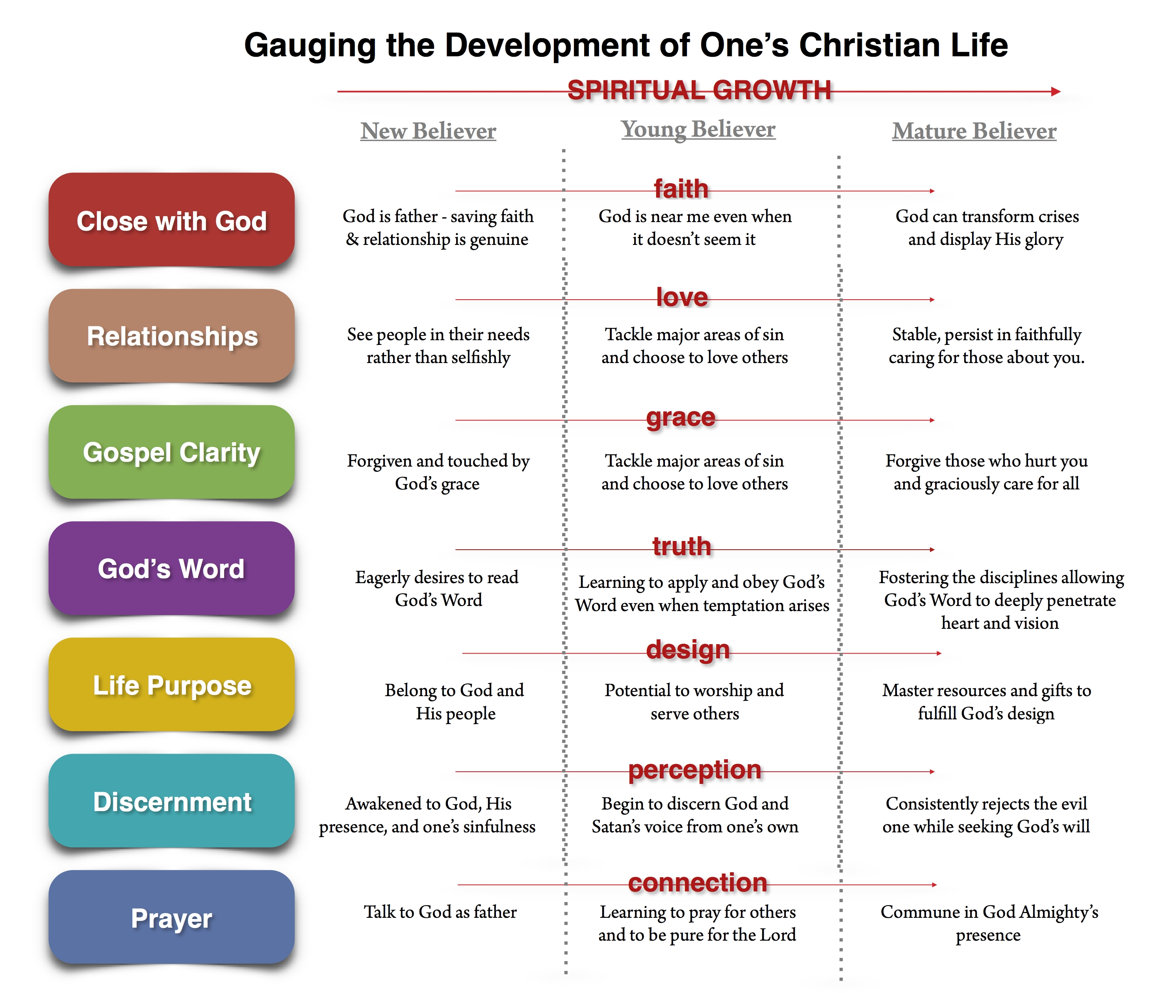

Anticipating Spiritual Growth in the Christian Believer
- Christians develop their knowledge and special skills dependent upon their _____ of spiritual development.
- Spiritual growth is the sum of how the Spirit of God has intentionally developed His child in various areas.
- Believers can grow in many more areas than above such as the discovery and use of spiritual gifts.
- The fruit of the Holy Spirit (Gal 5:22-23) enable and complement others aspects of spiritual development.

Questions
- What is one way that you would like to grow in spiritual discernment?
- Scan the above diagram and share one aspect that you have learned about spiritual growth.

