Oakland International Fellowship Paul J. Bucknell

Revelation 22:20-21 Handout
Epilogue & Review of Revelation’s Message
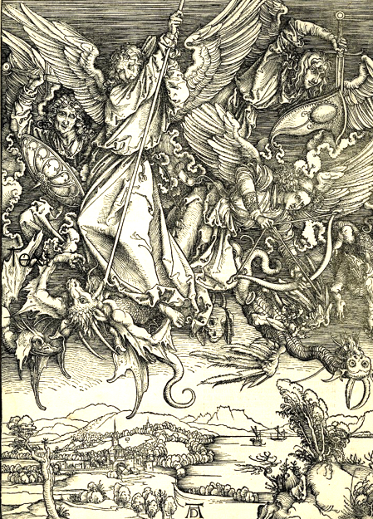
Revelation’s cleverly designed network of dramas, each with 7 components highlight what John heard and saw, powerfully edifies her listeners, “Blessed is he who reads and those who hear the words of the prophecy, and heed the things which are written in it; for the time is near” (Rev 1:3). The reader is unconsciously drawn deep into each scene, creating a deeper awareness of the spiritual world around them.

A. The Profit from Revelation
“The revelation of Jesus Christ, which God gave Him to show to His bond-servants, the things which must shortly take place; and He sent and communicated it by His angel to His bond-servant John” (Rev 1:1).
- How does God’s revelation help us? Revelatory knowledge enables us to know what otherwise is unknowable, directing us to prioritize what is truly important.
- What more can we know from Revelation? The Book of Revelation raises awareness and alertness, further shaping our commitment to live godly lives to the end.
- What can we not know from Revelation? God uses the Book of Revelation to strengthen our confidence and faith rather than provide specific dates and events of Jesus’ second coming (Ac 1:6-11).

B. The Meaningful Structure of Revelation
The scheme of Revelation: “Write therefore the things which you have seen, and the things which are, and the things which shall take place after these things” (Revelation 1:19).
The scenes overlap because they typically describe the same event(s) from different perspectives.
“The scenes of revelation have brought us to the world’s end at each sixth section, and at each seventh section have shown us the triumph of Christ.” (Wilcock, p. 203)
- The scenes are progressively intensive. Our earthly view is dull because it excludes the heavenly realities.
“It is as if we have passed through a series of seven-sided rooms, in each of which one window has looked out on to eternity; and in a moment we shall step out of the seventh room and find ourselves in the open air.” (Wilcock, p.198)
- The scenes gradually move from earthly (7 churches in Rev 2-3) to heavenly views (Rev 21-22).
“Scene 8 takes up the seventh sections of nearly all the previous scenes, and blends them into a single but complex picture of the life of the world to come.” (Wilcock, p.198)
- The overlapping pictures and chiastic structures necessarily exclude a historical chronology.
4 Openings (1-4)-opening out + 3 Endings-closing (5-7) (From Wilcock’s Message of Revelation)
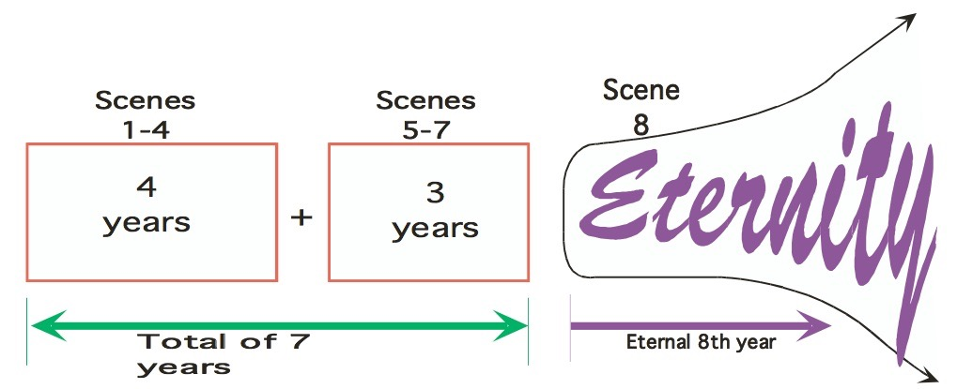
Summary: The structural framework is clearly seen in some sections (7 churches, 7 seals, 7 trumpets, 7 bowls) and somewhat disguised (or debated) in the others, but the conclusions are the same.

C. Revelation’s Epilogue (Rev 22:20-21)
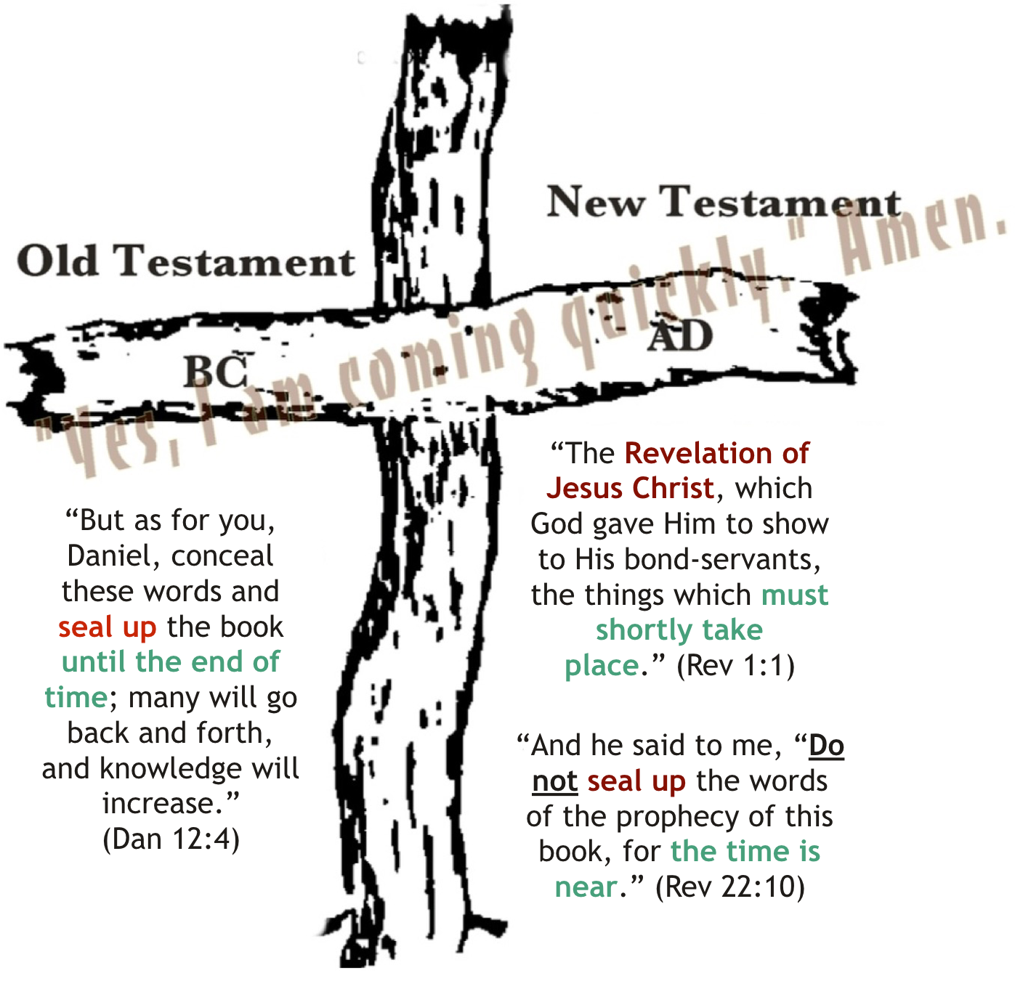
“²⁰ He who testifies to these things says, ‘Yes, I am coming quickly.’ Amen. Come, Lord Jesus.
²¹ The grace of the Lord Jesus be with all. Amen” (Rev 22:20-21).

Three Quotes:
- “I am coming quickly.”(20b): The pure church readies herself for Christ’s coming.
- “Amen. Come, Lord Jesus.” (20c): The holy church has a deep desire to be with Christ.
- “The grace of the Lord Jesus be with all.” (21): God’s people recognize their need for God’s grace during these last days.
Summary: The Revelation of Jesus Christ (1:1) ends here with the church either in the heavenlies rejoicing in His presence or with the remaining saints on earth longing for the coming of the Bridegroom along with the full revelation of Jesus Christ.

D. Problems Understanding Revelation
One of the main questions that we have been facing throughout the study of Revelation is, “Why is it that we are so easily confused rather than illuminated through our study of Revelation?”
- Uncomprehensive: Glimpses of the spiritual world shake up our basic understanding of life (Rev 21:1-2).
- Ignorant: Inadequate understandings of OT scriptures and Revelation invite us to further dive into the ocean-like pool of God’s holy Word.
- Misguided: We presume Revelation is discussing something which it is not. Shaped by modern evangelicalism, many suppose that Revelation is a book determining the timing of Christ’s return.
- Speculators: We are not asking the questions most Christians around the world are asking. Revelation is written to the persecuted. We treat eschatology (study of last times) as a curious question where many Christians are looking for a reason to keep believing due to extreme pressures.
- Doubtful: We wonder how the Lord allows His beloved people to be assailed while on earth (Rev 6:9-10).
- Secretive: The presence of evil does not reflect God’s weakness but His special purposes (Rev 4:11).
- Unconvinced: Christ, the only and mighty sovereign, is at all times fully in charge (Rev 1:17-18).
Summary: The book of Revelation answers the two questions, “Why has Christ not yet come back?” and “Is Christ really in charge with so much evil around?” rather than, “When is Christ going to come back?” Jesus emphatically requests His disciples not to focus on the times of the end but our responsibilities (Acts 1:7-8).
Conclusion
The Lord is chiefly concerned with helping believers persevere in godly living through this brief evil interim on earth, especially when false teachings and persecution urge compromise among His people. Our hope for Christ’s return depicts a fixed heart, not being caught up in the world but instead waiting on Him in faith.

Discussion Questions
- What is the most important truth, image, or phrase that has helped you in the study of the Book of Revelation? Why is it important to you?
- How important is it that we believe Christ is returning soon? Many doctrinal statements include “believe in the near return of Jesus Christ.” How does verse 22:20 shed light on the importance of this?

