Paul J. Bucknell Oakland International Fellowship

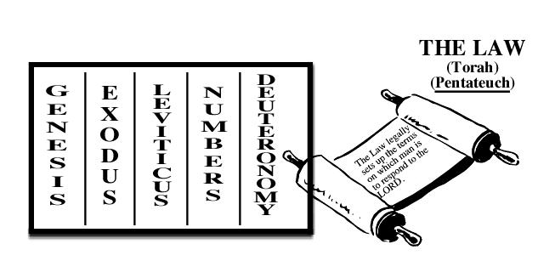
#1 Introduction to Genesis
- A Brief Introduction to Genesis
- “If the foundations are destroyed, what can the righteous do?” (Psalms 11:3)
- Only with the foundations from God’s Word, can we understand, choose, and commit to God’s kingdom.
- Our ___________ in life depends on how closely we align our lives to God’s foundation, the foundation of foundations.
“He only is my rock and my salvation, My stronghold; I shall not be shaken. On God my salvation and my glory rest; The rock of my strength, my refuge is in God. Trust in Him at all times, O people; Pour out your heart before Him; God is a refuge for us” (Psalms 62:5-8).
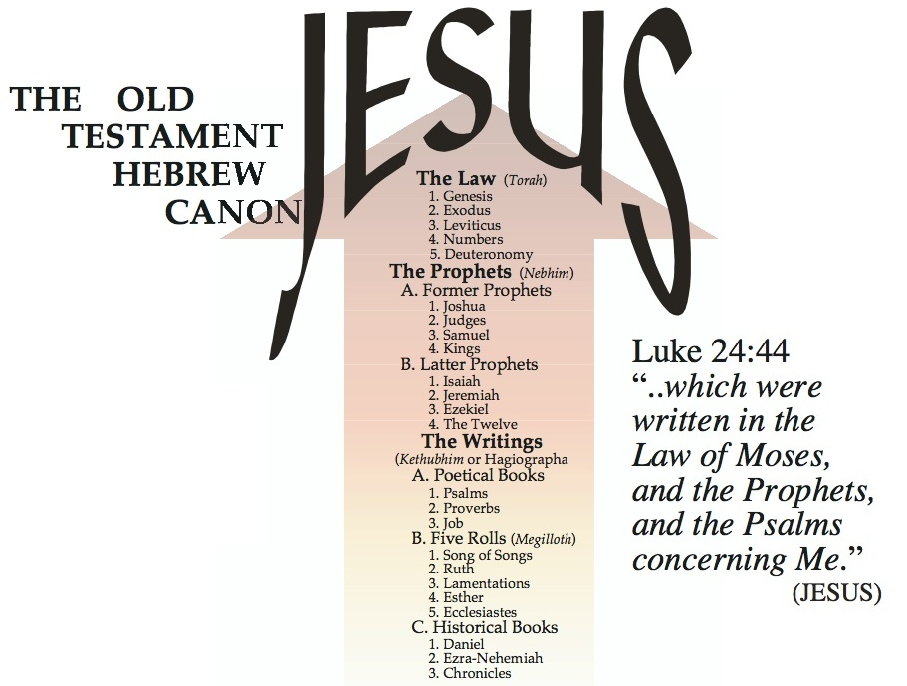
- The Importance of Genesis
- Genesis (literally ‘beginning’ or ‘chief’) is the first book of the Law (Pentateuch-Torah including all five books).
- God’s Word written by Moses. “And it came about, when Moses finished writing the words of this law in a book until they were complete, that Moses commanded the Levites who carried the ark of the covenant of the LORD, saying, ‘Take this book of the law and place it beside the ark of the covenant of the LORD your God, that it may remain there as a witness against you’” (Deut 31:24-26).
- The Jews and Jesus taught the unity of the Hebrew scriptures in three sections (Luke 24:44):
__________ _____________ ___________
- The underlying purpose of the Old Testament (lit. covenant) scriptures is to reveal the person and work of Jesus the Messiah (lit. Christ).
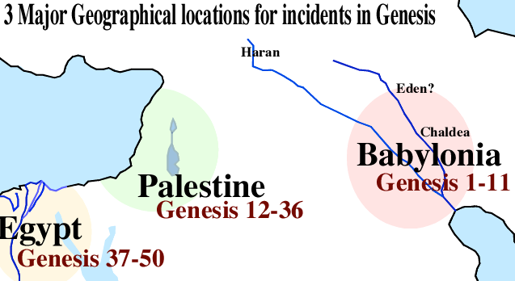
- The Unity and Reliability of Genesis

Geographical Outline of Genesis
  - Note the three major geographical locations in Genesis:
  - __________________ (1-22)
  - __________________ (12-36)
  - __________________ (37-50)

Genealogical Outline of Genesis
1:1-2:3 Prologue
“In the beginning God created the heavens and the earth” (Gen 1:1).
============
2:4-4:26 The Generations of Heaven and Earth “This is the account of the heavens and the earth when they were created, in the day that the LORD God made earth and heaven” (Gen 2:4).
5:1-6:8 The Generations of Adam
“This is the book of the generations of Adam. In the day when God created man, He made him in the likeness of God” (Gen 5:1).
6:9-9:29 The Generations of Noah
“These are the records of the generations of Noah…” (Gen 6:9).
10:1-11:19 The Generations of Noah’s Sons
“Now these are the records of the generations of Shem, Ham, and Japheth, the sons of Noah; and sons were born to them after the flood” (Gen 10:1).
11:10-26 The Generations of Shem
“These are the records of the generations of Shem…” (Gen 11:10).
11:27-25:11 The Generations of Terah
“Now these are the records of the generations of Terah…” (Gen 11:27).
25:12-18 The Generations of Ishma
“Now these are the records of the generations of Ishmael, Abraham’s son, whom Hagar the Egyptian, Sarah’s maid, bore to Abraham” (Gen 25:12).
25:19-35:29 The Generations of Isaac
“Now these are the records of the generations of Isaac, Abraham’s son…” (Gen 25:19).
36:1-37:1 The Generations of Esau
“Now these are the records of the generations of Esau (that is, Edom)” (Gen 36:1).
37:2-50:26 The Generations of Jacob
“These are the records of the generations of Jacob. Joseph,..” (Gen 37:2).
- Genesis is composed of ten genealogies, each introduced by the same Hebrew word meaning ‘records of the generations’ (Hebrew - Toledot).
- An impressively organized collection of records with a singular focus to identify God’s redemptive lineage and plan.

Demonstration of Genesis’ Unity
- Genesis’ unity is evident through the community’s understanding, Jesus’ teaching, clear outlines and interweaving themes.
- The underlying assumptions from which some espouse numerous authors are inconsistent (e.g., Documentary Hypothesis suggested authors: JEDP). Note: Jahweh (J–Yahweh) and Elohim (E–God) used together (Gen 2:4).
- Meticulous scribal work preserved the _________ text (11th c.)
- Dead Sea Scrolls (www.deadseascrolls.org) ancient (1-2 cent. before Christ) Hebrew manuscripts of all Bible books except Esther.
- The Genius of Genesis

Various biblical approaches to understanding Genesis
- SEEDS: Genesis is the ground where seeds of life and truth are scattered throughout time to be sown in our minds.
__________ _________ _________ _________ _________
- GENES: Genesis is the gene pool of truth, largely unseen but very influential much like a computer code for an app.

- __________: Genesis carefully introduces a powerful story line full with key characters and intriguing events (Gospel plot).
- PROPHECY: Genesis with powerful accuracy predicts future events (Gen 3:15-16).
- HISTORY: Genesis is the key unlocking the link between ancient and modern history.

Summary: The Success of Our Lives
- Genesis provides a theological and moral framework that we can build our lives upon (e.g., marriage, troubles, God’s presence, human beings special design and calling, etc.,).
- Genesis directs us to ask the right questions so that we search for and find the needed answers.
- God spoke the world into being (general revelation) and wrote to us communicating His thoughts (special revelation).
Discussion Questions
- What part of Genesis has helped you most from your past study of the book?
- How is Genesis said to set a foundation for our beliefs and lives?
- Give several reasons for the trustworthiness of the Genesis scriptures.

