
Paul J. Bucknell Oakland International Fellowship

#2 Creation and the Worship of God
Genesis 1:1-2:3
Develop honor for our Creator and respect for others
What is God like? What do we know about the world? How are people unique?
“In the beginning God created the heavens and the earth. 2 And the earth was formless and void, and darkness was over the surface of the deep; and the Spirit of God was moving over the surface of the waters. 3 Then God said, “Let there be light”; and there was light. 4 And God saw that the light was good; and God separated the light from the darkness. 5 And God called the light day, and the darkness He called night. And there was evening and there was morning, one day” (Genesis 1:1-5).
- God’s title - ‘God’ 34x _E________
- God’s word - ‘Let’, ‘Said’
- God’s thoughts - ‘Called’
- God’s power - ‘created’, ‘made’
- God’s goodwill
- God’s wisdom - 7th day completed
- Our understanding of God, the world, and people largely come through the Genesis creation account.

A. 3 Absolutes to Know from Genesis 1
- _________ is Creator
People are His creation and are wholly dependent upon Him for all. (Is 42:5)
  - God’s glorious attributes are __________ through creation.
  - God’s power, eternal nature, His love, beauty, and goodness are clearly seen.
  - His order, design, and purposes are everywhere enjoyed.
  - No doctrinal statement is as powerful as the record of God's mighty works in Genesis 1.
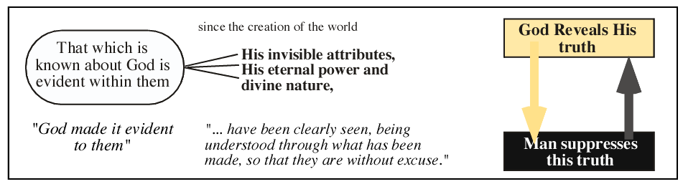
Romans 1:18-21

- God created a _________ world (Ps 145:9)
God made a great and good world in which we can _______ His care for us.
  - God’s goodness - ‘was good’, 7x F_ _ T _ _ T _ _
  - Created (more intricate works; ex nihilo) versus Made (fashioned)
  - God is wise - 7th day rested shows completion; the design was embedded.
  - God is interested in our well-being (created the world to fulfill that goal).
  - As our Maker, God brought us into existence.
  - As our Designer, He has seen through all the details of our lives.
  - As our Provider, He adequately provides for all our genuine needs. (e.g. symbiotic)
- God made people to __________ to Him.
God purposely made us enjoy what He has made, _________ to Him, and work with Him in this world.
- Both male and female were created in ______ image.
- Each gender specially reflects God’s person and purpose.
- “But from the beginning of creation, God made them male and female” (Mark 10:6). –Jesus
- God made man to responsibly relate to Him rather than being an ignoble mass of random atoms.
Summary: The Gospel is found in Genesis 1: God’s goodwill welcoming us in His fellowship.

B. Creation’s Design
- An ordered Creation
    - 7 Days
    - Truth: sequenced, purposed, designed versus Falsehood: Chaos, meaningless, incomplete, chance
    - General revelation (Gen 19:1-6): Truth from God’s ___________
    - Specific revelation (Gen 19:7-14): Truth from God’s __________
    - Alternate interpretations arise because of a felt need to reconcile knowledge with one’s faith.
- Creation versus Evolution
    - Life is a miracle. “It is the most improbable event in the universe,” says British biochemist (M. Dixon).
    - Gap theory (an indeterminate amount of time inserted between verses 1:1-2).

Notes
    - Day - Age Theory: Each day is an age
    - Framework Hypothesis: Genesis 1-3 is partly poetic, symbolic
“One must do a great deal of hermeneutical gymnastics to escape the plain meaning of Genesis 1-2” (Sproul).
    - Six-Day Creation (young earth): Take literally as Jesus did.
The Genesis Flood by John C. Whitcomb and Henry M. Morris
“By faith we understand that the worlds were prepared by the word of God, so that what is seen was not made out of things which are visible” (Heb 11:3).

C. Creation’s Purpose
  - Man is expected, like the rest of creation, to completely join in with God’s plan.
  - Genesis 1 destroys the many barriers man has presented by excusing his disobedience by presenting how intimately He is involved in our lives.
  - Man’s greatest knowledge comes from understanding his life in relationship with God’s purpose for his life.
  - Man’s greatest peace comes from living in harmony with God’s purpose for his life.

Summary
    - God made us to know and obey Him.
    - God spreads out the universe to capture our hearts and minds in worship and adoration
    - God made us in His image so we can know Him and thoroughly delight in Him and what He has made.
    - God’s goodness is evidenced by the way He sent His Son Jesus into our sin-warped world and lives, restoring us to His glorious kingdom purposes.

Discussion Questions
    - Do you think everyone is obligated to worship God? Explain.
    - Why is there no inconsistency between the Bible and truth found through science?
    - Why should we believe there is a literal creation as presented in Genesis 1?

