Paul J. Bucknell Oakland International Fellowship

#8 Preservation of the Godly
Genesis 5-9
From the Beginning of Time
- Genesis, including the flood, form historical markers noting God’s extreme grace towards mankind.

A. From the Beginning of Time (Genesis 5:1-11)
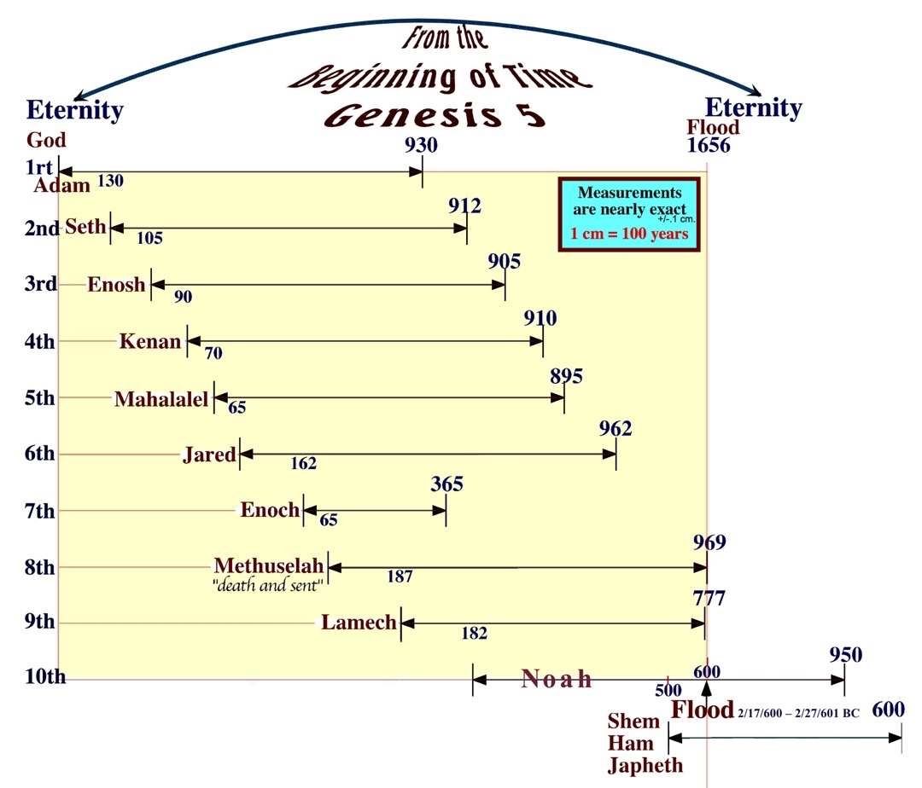
5:1 “This is the book of the generations of . In the day when God created man, He made him in the likeness of God. 2 He created them male and female, and He blessed them and named them Man in the day when they were created. 3 When Adam had lived one hundred and thirty years, he became the father of a son in his own likeness, according to his image, and named him Seth.”

Scaled

• The Generations of Adam (Gen 5:1)
  - Adam’s record (2nd/10) - “This is the book of the generations of Adam” (5:1). Noah is 3rd record (6:9).
- The accuracy of the genealogy: The age of the father had a son (Adam 130…Seth 0) (Gen 5:3)
“And Seth lived one hundred and five years, and became the father of Enosh. 7 Then Seth lived eight hundred and seven years after he became the father of Enosh, and he had other sons and daughters” (6-7).
  - Image passes on. “In the day when God created man, He made him in the likeness of God” (5:1).
“He (Adam) became the father of a son (Seth) in his own likeness, according to his image” (5:3).
“Put on the new self who is being renewed…according to the of the One who created him” (Col 3:10).

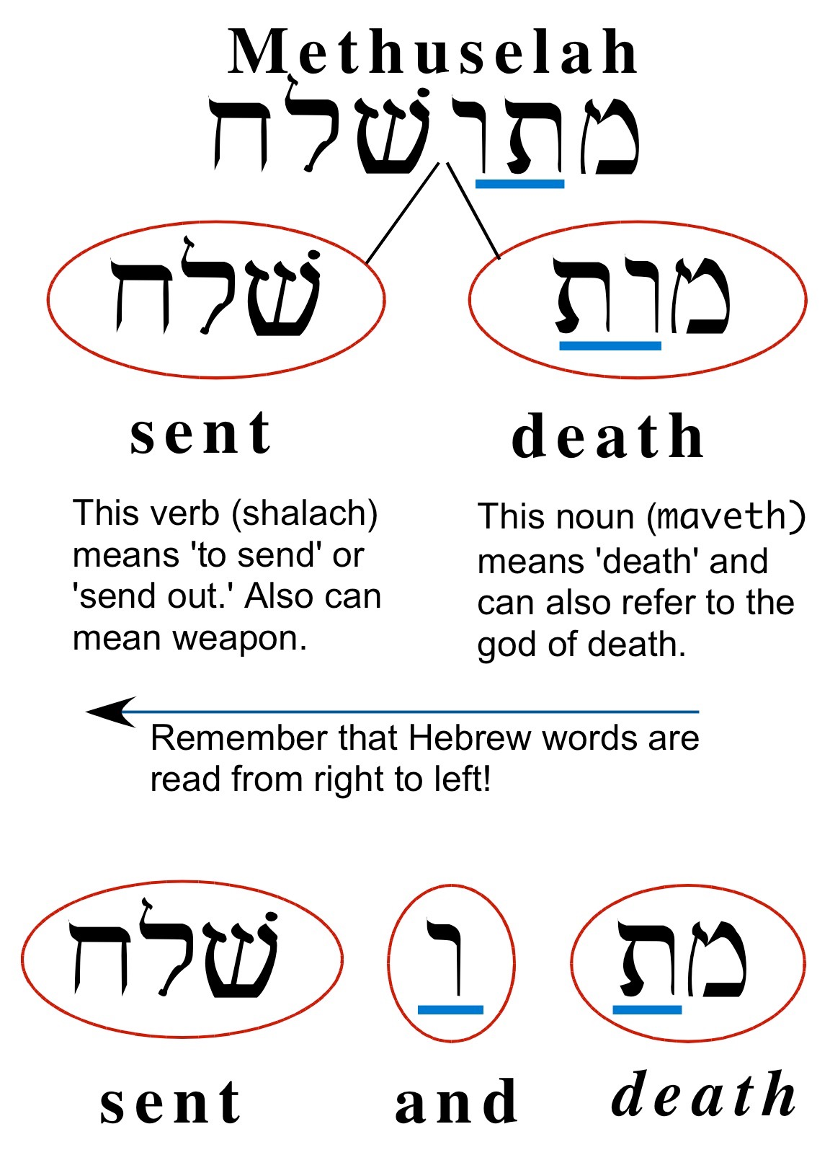
B. Enoch’s Secret Word: Methuselah (Gen 5:21-25)
“Enoch lived sixty-five years, and became the father of Methuselah. 22 Then Enoch walked with God three hundred years after he became the father of Methuselah, and he had other sons and daughters. 23 So all the days of Enoch were three hundred and sixty-five years. 24 And Enoch walked with God; and he was not, for God took him. 25 And Methuselah lived one hundred and eighty-seven years, and became the father of Lamech (Gen 5:21-25).
- Methusaleh = _______ and _______ means _______________________________.
- Cosmic happening at death 1656 (see chart)
- Great prophecy:
“And about these also Enoch, in the seventh generation from Adam, prophesied, saying, “Behold, the Lord came with many thousands of His holy ones, to execute judgment upon all, and to convict all the ungodly of all their ungodly deeds which they have done in an ungodly way.…” (Jude 14-15) ___ Circle Enoch (7th generation) in above chart.

C. Sons of God (Gen 6)

1 Now it came about, when men began to multiply on the face of the land, and daughters were born to them, 2 that the sons of God saw that the daughters of men were beautiful; and they took wives for themselves, whomever they chose. 3 Then the LORD said, “My Spirit shall not strive with man forever, because he also is flesh; nevertheless his days shall be one hundred and twenty years.” 4 The Nephilim were on the earth in those days, and also afterward, when the sons of God came in to the daughters of men, and they bore children to them. Those were the mighty men who were of old, men of renown (Gen 6:1-4).
  - Identification of “Sons of God” – “saw that the daughters of men were ___________.”
  - Identification of Nephilim (Literally “_________” or renown)
  - Compromise often begins by marrying ___________ of one’s faith (1 Cor 7:39).

D. Judgment and Noah (Gen 6-9)
6:7 “Then the LORD saw that the wickedness of man was great on the earth, and that every intent of the thoughts of his heart was only evil continually… 8 But Noah found favor in the eyes of the LORD. 9 These are the records of the generations of Noah. Noah was a righteous man, blameless in his time; Noah walked with God. 10 And Noah became the father of three sons: Shem, Ham, and Japheth. 11 Now the earth was corrupt in the sight of God, and the earth was filled with violence.”
    - “Favor” of Noah (8) – Why does God bother to save Noah?
    - Extreme wickedness of mankind (5,11)
    - Without God’s grace man declines into evil
    - Preservation of God’s people
      - Ark ____________ the godly: “And did not spare the ancient world, but preserved Noah, a preacher of righteousness, with seven others, when He brought a flood upon the world of the ungodly” (2 Pe 2:5).
Visit the ark! www.arkencounter.com
      - The world goes on until…“They were eating, they were drinking, they were marrying…, until the day that Noah entered the ark, and the flood came and destroyed them all” (Lu 17:27). How bad are we now?
Summary Pattern: Danger of world => Solution => Means
    - Gen 6-9: Intermingling by marriage => Purged the wicked => Restarts anew with __________ (The Ark)
    - Gen 11: World’s strong power => Slows deterioration by isolation => Creates sub-societies by _________
    - Gen 12: Swallowed by pagan culture => Births His nation => Calls _________ from Ur to Promised Land
    - Gen 37-50: Dependent on world power => Keeps separate in Egypt => Places __________ to keep them
Discussion Questions
    - Does God still judge the world?
    - How do we maintain a fervent love for God in this wicked world?
    - How does Jesus help us restore the image of God?

