Paul J. Bucknell Oakland International Fellowship

Unity & Diversity
Genesis 10-11 – Noah’s Sons & Babel
- Chapters 10 and 11 use successive genealogies and careful explanations of ‘modern’ phenomena such as the diversity that derives from the multiethnic societies and multitude of languages to connect the ancient past from the present. Why is this so important? Secularism is dependent on a disconnect from the Biblical record. If people realized that we share common roots with Adam and Eve, then they would have to face the God who created and designed them.
- 

A. Genealogy: Unity & Diversity (Genesis 10)
Genesis 10:1 “Now these are the records of the generations of Shem, Ham, and Japheth, the sons of Noah….”
Genesis 11:10 “These are the records of the generations of Shem….”

Noah and His Three Sons
  - The genealogy of chapter 10 shows how all the people of the world derived from these three sons of Noah: Japheth, Ham and Shem. Shem’s generations are expanded in chapter 11. Genesis 10 and 11 both begin with the characteristic introductions found throughout the Book of Genesis (toledot sections).
  - The genealogy takes a bit different course here. Chapter 10 does not record dates. We find no information of how old Shem, Ham and Japheth are. We only know about Shem’s line from Genesis 11.

A United History (Genesis 10:6-11)
“And the sons of Ham were Cush and Mizraim and Put and Canaan. And the sons of Cush were Seba and Havilah and Sabtah and Raamah and Sabteca; and the sons of Raamah were Sheba and Dedan. Now Cush became the father of Nimrod; he became a mighty one on the earth. He was a mighty hunter before the LORD; therefore it is said, “Like Nimrod a mighty hunter before the LORD.” And the beginning of his kingdom was Babel and Erech and Accad and Calneh, in the land of Shinar. From that land he went forth into Assyria, and built Nineveh and Rehoboth-Ir and Calah” (10:6-11).
  - At first, this might look like a very boring list of names. As we take a thorough look, however, we find a summary of ancient history. Ham was the son of Noah. Cush was one of Ham’s sons. Cush had his own son and named him Nimrod (great grandson of Noah).
  - Nimrod started his city-building campaign in what we now know as southern Iraq in the plains of Shinar (Mesopotamia), the land between the two rivers. Babel (Genesis 10:10) is Babylon (near modern day Bagdad). Accad (Akkad) is known for the ancient language Akkadian. Erech is suggested to be Uruk of Gilagamesh’s epic. Many scholars assert Gilgamesh is indeed Nimrod himself. Cush’s city was named after him Kish. Mosul. Nineveh. Calah (Gen 10:11 also in Iraq 20 m. SE of Mosul).
  - Genesis 10 provides a clear background of the Tower of Babel. Genesis 10 and 11 cannot be separated. Neither should modern history be disconnected to ancient history as described in the scriptures.

B. The Tower of Babel (Genesis 11:1-9)
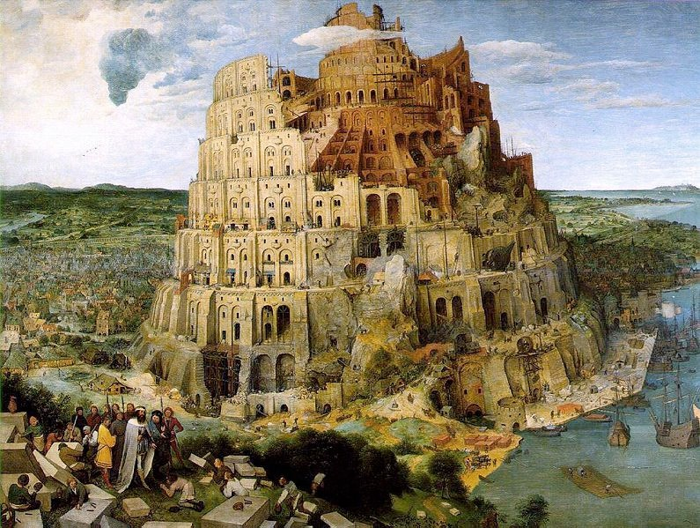
“Enoch lived sixty-five years, and became the father of Methuselah. 22 Then Enoch walked with God three hundred years after he became the father of Methuselah, and he had other sons and daughters. 23 So all the days of Enoch were three hundred and sixty-five years. 24 And Enoch walked with God; and he was not, for God took him. 25 And Methuselah lived one hundred and eighty-seven years, and became the father of Lamech (Gen 5:21-25).
- The sin of Noah and his son was shown us (Genesis 9:20-27) to remind us about the inherent flaws of the new society that would form after the flood.
- The Tower of Babel is one of many ziggurats that were built in the early Mesopotamian plain. They each seem to have a temple on the top of them
- Most interesting is a quote from King Nebuchadnezzar about the Tower of Babel (Babylon). Nebuchadnezzar referred to the people building it abandoned it because “without order expressing words.” This no doubt refers to the language confusion. Words were without order.
- The temple mound of Babel is still there today as shown in the Google Earth satellite picture above (bottom right).

The Date of the Tower of Babel
‘When all men were of one language, some of them built a high tower, as if they would thereby ascend up to heaven; but the gods sent storms of wind and overthrew the tower, and gave everyone his peculiar language; and for this reason it was that the city was called Babylon.… After this they were dispersed abroad, on account of their languages, and went out by colonies everywhere; and each colony took possession of that land which they lighted upon, and unto which God led them; so that the whole continent was filled with them, both the inland and maritime countries. There were some also who passed over the sea in ships, and inhabited the islands; and some of these nations do still retain the denominations (i.e. names) which were given to them by their first founders; but some also have lost them…” (Josephus. Antiquities of the Jews. i. 5.).
The date of the Tower of Babel is not quite clear. It clearly fits into ancient history of the Sumerians. We do not know, however, where it fits in the above genealogical chart. The flood is quite clear because it was person specific, that is, Noah’s sons were already grown up (Shem was 100 hundred years old). Dates were supplied.
The Tower of Babel account in Genesis 11:1-9 does not provide these dates. Genesis 10:25 appears to refer to the Tower of Babel. “And two sons were born to Eber; the name of the one was Peleg, for in his days the earth was divided; and his brother’s name was Joktan” (Genesis 10:25). Their point is that the division referred to in the verse is the actual division of mankind that occurred due to the mutually intelligible languages. “So the LORD scattered them abroad from there over the face of the whole earth; and they stopped building the city” (Genesis 11:8). Others suggest that this division in Peleg’s day refers to the splitting of the continents. The former seems more likely.

Man’s Plan (Genesis 11:1-5)
  - Man’s suburbia tendencies (explore) “Go where no man has gone!”
  - Step #1: Ready the materials.
  - Step #2: Build a city and tower.
  - Purpose: Become famous - be an attracting point.

God’s Assessment (Genesis 11:5-9)
  - The Lord’s Observation (5)
  - The Lord’s Conclusion (6-7)
  - The Lord’s Accomplishment (8-9)
Development of Language (Genesis 11:1-9)
- A mono-lingual world is difficult for a world traveler to comprehend.
- Some speculate that Hebrew was the original language (Edenic language). Isaac Mozeson, author of “The Word: The Dictionary that reveals the Hebrew roots of the English Language” is convinced of this. Below he writes,
- “Percentage-wise and vocabulary-wise, English is more obviously a dialect of Hebrew than of Latin, Greek or French. When Noah Webster’s original dictionary traced many English words beyond German, French, Latin and Greek to their “Shemitic” origin, no one raised an eyebrow.
    - Genesis unashamedly confronts secularism. Secularism asserts that man has no roots back to God. They live for the moment. Genesis states the world around us and man’s origins are founded by and for God, making mankind dependent upon Him. Since we all are made for God, personal fulfillment can only be found by living for God’s purposes.
    - The division of world cultures decelerated the speed of evil but today’s unifying world culture is accelerating evil.
    - People from different cultures are able to communicate with people from different areas. Education has increased the usage of world languages like English. India with its vast number of isolated villages with their own languages are fast become evangelized. Over the last twenty years an amazing 400,000 churches have started.
Discussion Questions
    - How does a people’s own language help create and preserve their culture?
    - What significance does unity have on the world and the church (Genesis 11:6; Acts 2:44-45; Acts 4:32-33)?

