
Paul J. Bucknell/Michael Lim Oakland International Fellowship

Responding to Life’s Challenges
Genesis 12-16, 20
Learning from other people’s mistakes
Our lives are full of events to which we must respond by faith in the Lord. Life detours result from a missing or misplaced faith bringing unnecessary consequences into God’s plans for us. A mature faith enables us to consistently trust God as our Guide, Provider, and Protector.

- Abram’s amazing faith
God intervened in Abram’s life, calling him to leave Ur and go to a promised land. Abram’s faith brought an awesome commitment from God to be with Abram and greatly bless him.
- Haven’t we all made some _______ life decisions?
Draw 3 lines to connect Abram’s detour with disobedience to God’s command on the left.
Despite Abram’s faith to leave Ur, his faith diminished into doubt in 3 key areas.
Now the LORD said to Abram,
“Go forth from your country,
And from your relatives
And from your father’s house,
To the land which I will show you
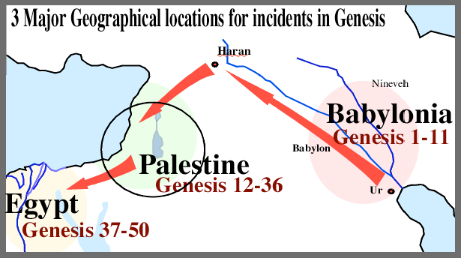
And I will make you a great nation
A. Place Detour (Genesis 12)
Went where he wasn’t supposed to
B. Person Detour (Genesis 13-14)
Stayed with those he shouldn’t
C. Procedure Detour (Genesis 16)
Did things in ways he shouldn’t
Watch where your stomach might lead you! (Gen 12)

1.) Place Detour (Genesis 12:10-20, 20)
=> Went where he wasn’t supposed to
“Now there was a famine in the land; so Abram went down to Egypt to sojourn there, for the famine was severe in the land” (Gen 12:10).
- Where did the Lord originally want him to go and why? _____________
- Abram went down to another country (Genesis 12:10-20).
- What country did Abram go to and why? _________________
  - How else could Abram have responded? _________________
3) Abraham went over to the land of the Philistines (Genesis 20).
• Movement: “Toward the land of the Negev, and settled between Kadesh and Shur; then he sojourned in Gerar” (20:1).
Abram step by step departs.
• Fear: Abraham said, ‘Because I thought, surely there is no fear of God in this place; and they will kill me because of my wife’” (20:11).
Watch were your resentment might lead you! (Gen 20)
• Resentment: “When God caused me to wander from my father’s house” (20:13).
This incident occurs after which significant event? _________
Disobedience => Insecurity => Fears => Immoral decisions
Obedience => Trust => Peace => Good decisions

2.) Person Detour (Genesis 13-14)
=> Being with those you shouldn’t
1) Abram and Lot’s Workmen (Genesis 13)
The first problem was over Abram and Lot’s ____________.
Note: The conflict arose with Lot due to Abram’s disobedience. The negative consequences, as always, was unnecessary though we can readily understand how ‘natural’ it was to feel more secure with Lot’s company.
2) Abram’s Rescue of Lot (Genesis 14)
The second problem of having Lot nearby led to getting caught in a risky fight.
Note: We logically speculate that Abram’s rescue of Lot and others put off the judgment on Sodom and Gomorrah. His courageous behavior did, however, remain as a strong witness. There are times we need to avoid the company of certain people/situations.

3.) Procedure Detour (Genesis 16-17)
=> Did things in ways he shouldn’t

1) The Difficulty
“Now Sarai, Abram’s wife had borne him no children, and she had an Egyptian maid whose name was Hagar” (Genesis 16:1).
The problem:
The temptation:

2) The Detour
“And after Abram had lived ten years in the land of Canaan, Abram’s wife Sarai took Hagar the Egyptian, her maid, and gave her to her husband Abram as his wife. And he went in to Hagar, and she conceived; and when she saw that she had conceived, her mistress was despised in her sight.” (Genesis 16:3-4)
- Application: Time tests our faith
_________ DETOURS
The World | The Godly | Evidence
World’s ways are  never best | God’s ways are  always best | Bad consequences
Seems compelling | Not really urgent | Waited 14 more years
Self-reliant | God-dependent | The miracle of Isaac
Prideful | Exalts the Lord | God supplies
Relativistic | Set on God’s principles | Abraham’s marriage
Lives by senses | Lives by faith | Abraham’s faith
- Don’t always follow the advice of your wife.
- The husband is responsible to do the right thing.

3) The consequences: Self-reliance is a huge problem.
  - Ishmael’s descendants became a major threat to ____________ (of Isaac the Promised son).
  - Further difficulties in Abraham and Sarah’s marriage (cf. Gen 16).
  - Unable to prove God’s faithfulness in his own life.
  - Poor testimony. (“I didn’t think there was such a God.”)

4) God’s solution
God wants us to withstand the enemy’s testing and endure the tests set before us.
Summary

When we face situations where choices must be made or challenges overcome, we must fully turn to the Lord so that we can avoid unnecessary detours which delay and hinder God’s work and blessing in our lives. Yet, even in his weakness and his numerous errors, Abram’s faith ultimately prevailed. We must do likewise, for our errors can become detours, but Christ covers all our sins so that by faith we may strive forward in His power and righteousness alone.

Discussion Questions

- What are spiritual detours and some of the costs of taking them?
- What specific difficulties and mistakes did faith allow Abram to overcome and avoid? (or would have allowed him to if he had shown faith)
- What specific challenge has faith helped you overcome or avoid?
When God speaks, listen carefully to details.
They might not make sense for a while, but they are important.

