Paul J. Bucknell Oakland International Fellowship

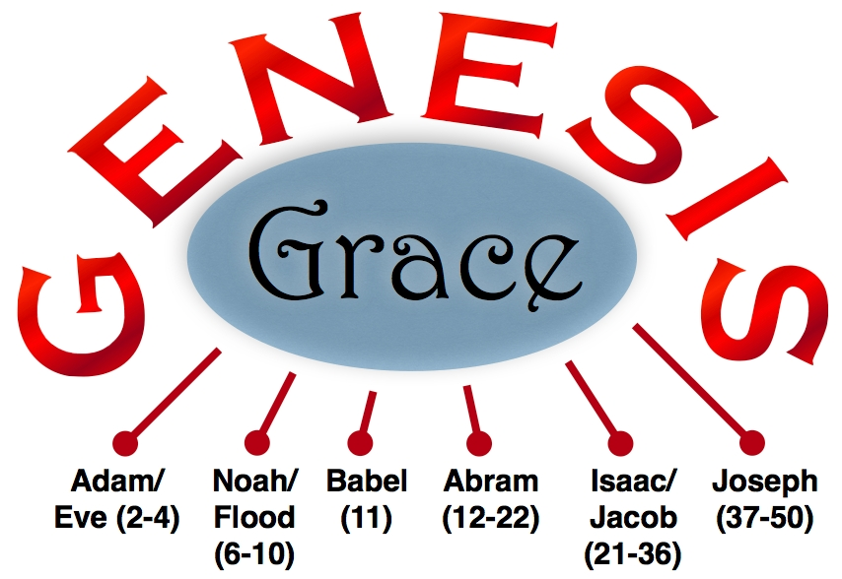
Making Tough Choices
Genesis 21-26
Our decisions are always important. They shape our future and reveal our hearts’ desires. By tracing some of Isaac’s key decisions, we can gain the needed wisdom to make right choices even in difficult situations.

Genesis: The Book of Foundations: G ___ ___ ___ E
Genesis provides a solid understanding of how God brings extreme grace into our unworthy lives, springing up hope even in our dire circumstances.

Genesis => Temple _________ => Jesus _________ => Revelation 21:2,11,14.

A Chronology of Isaac’s Life (Gen 21-35)
- Isaac’s birth (21):
- Isaac’s teenage experience (22): Mount _________
- Isaac’s trauma of losing his Mom (23)
- Isaac gets married at 40 only after a huge miracle (24). “God’s choice”
- Isaac begins to seriously pray (25)
- Isaac’s dad dies and inherits all (25)
- Isaac’s own testing and proving (26)
- Isaac dies at 180 years old (35:28)
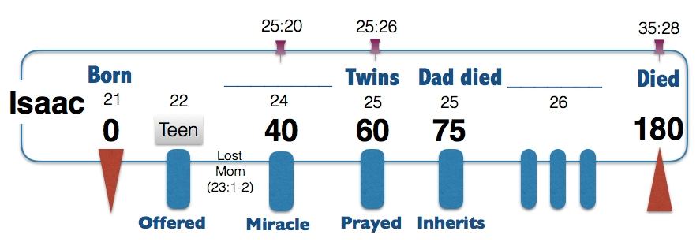

#1 Struggles Bring Focus (Gen 25:1)
“And Isaac prayed to the LORD on behalf of his wife, because she was barren; and the LORD answered him and Rebekah his wife conceived” (Gen 25:21).
- Was Rebekah too bitter to pray? Did he not pray earlier?
- Sometimes only difficulties can get a husband involved!
- Difficulties test what I really want, asking if it really matters.

#2 Womb War Casts Vision (Gen 25:22-24)
“But the children struggled together within her; and she said, “If it is so, why then am I this way?” So she went to inquire of the LORD. 23 And the LORD said to her, “Two nations are in your womb; And two peoples shall be separated from your body; And one people shall be stronger than the other; And the older shall serve the younger.” 24 When her days to be delivered were fulfilled, behold, there were twins in her womb” (Gen 25:22-24).
- Puzzles in life get us seeking the Lord (if not embittered).
- God revealed an answer to Rebekah’s question.

Election of God’s People (Genesis 25:22-23)
- The Lord gave these clues to help them not get confused by normal
life expectations and keep on the spiritual track.
- God reveals His choice of the second born, “born again”–Jn 3:3,10
- Through these words we see God’s intervention in man’s affairs.
- God’s plan for us begins before we are born (Gen 25:23).
- God’s plan begins before the world or time existed (Eph 1:4).
- Why does predestination bother people? (Eph 1:4-5; Ps 135:4; Is 41:8; Mal 1:2-3; Rom 9:10-16)

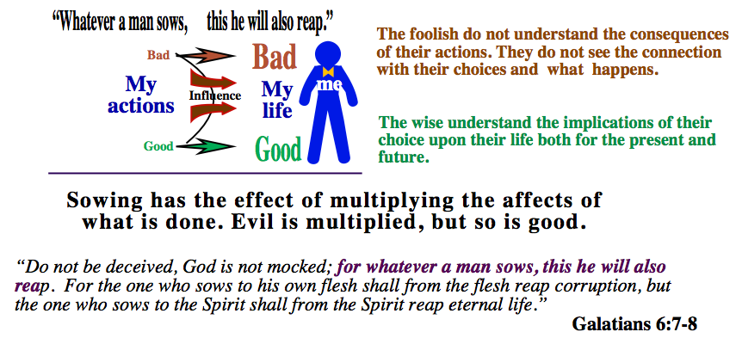
#3 Drifts from and Returns to God (Gen 26)
Genesis 26:1-11
- A famine in the land - What to do?
- Isaac leaves for ________, but __________ appears to him (26:2).
- Why warned not to go to Egypt?
- God gives him vision to direct his life choices.
- Abraham is seduced by the world’s pressures.
Genesis 26:12-25
- The Lord’s greatly blesses Isaac.
- “Go away from us” and the struggle with wells
- Earthly contentment: Finally, ____________ - no contention
- Spiritual discontentment: Content but moves to ______________
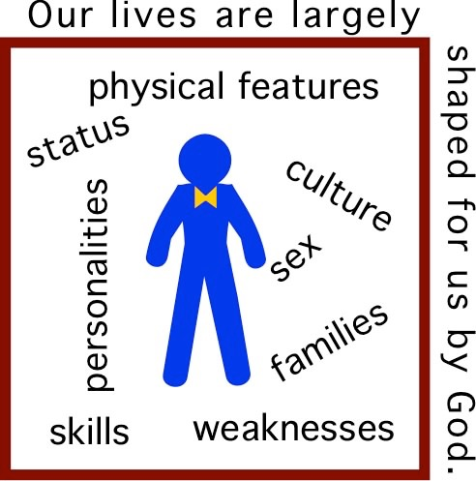
“23 Then he went up from there to Beersheba. 24 And the LORD appeared to him the same night and said, “I am the God of your father Abraham; Do not fear, for I am with you. I will bless you, and multiply your descendants, For the sake of My servant Abraham.” 25 So he built an altar there, and called upon the name of the LORD, and pitched his tent there; and there Isaac’s servants dug a well” (Ge 26:23-25).
- Influence from surrounding cultures
- When he departed from Gerar’s culture, he experienced a new freedom.
- Though securing an uncontested well, he suddenly left it and the world.
- The Lord, then, again revealed Himself to him.
- Isaac responded by building his first altar.
Each of us, like Isaac, must possess our own faith.

#4 Getting a Life Perspective
- God’s “unchangeables” include person’s, parents, and situations!
- We must focus on what we can change through our choices.
- “Why has God put me in this situation?”
- “What is God’s life purposes for me?”
- “Have I pursued the Lord above all?”

Summary
- Don’t fear life’s difficulties but use them as stepping stones to experience more of God.
- Be grateful for your “unchangeables” from God. Focus on making wise choices.
- Be attentive to God’s grace even during our failures.
- Worldliness can destroy a vivacious faith.
- God awaits expression of our clear commitment towards Him.

Discussion Questions
- Why does the Lord allow famines to be part of the lives of His people whom He blesses?
- God is not troubled with His free choice, are you? Why? How do you resolve issues regarding free will?
- Identify anything that might prevent you from “building an altar” signifying that your life now centers on serving God and not yourself.

