
Paul J. Bucknell Oakland International Fellowship


The Making of a Man of God
- Jacob
- Joseph
Genesis 31-32
Each believer travels on a spiritual journey whether or not he/she realizes it. No matter what our expectations of life, God’s hand powerfully shapes our lives. His sanctification deeply works in our lives so that we might effectively serve Him. By observing how God worked in Jacob’s life to bring him closer to Himself, we can learn some key lessons how He leads us in our spiritual lives!

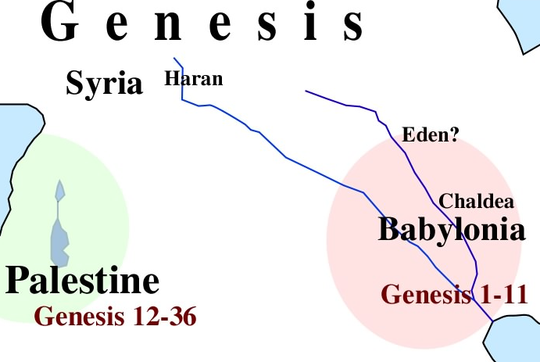
1) Jacob’s Changing World (31)
Jacob returns home
Losing everything once (i.e. Esau, family) was bad enough when fleeing his brother Esau. But now, it is happening again!
- Observation: Signs of Change (31:1-5)
“It (father’s attitude) is not friendly toward me as formerly” (5). Those things he worked doubly hard for were threatened, causing great insecurity.

- Evaluation: Retells of God’s Grace (31:6-16)

Hardships (Gen 31:38-42a)

Jacob reveals his plan to escape this loss by sneakily returning to his homeland where God had spoken to him.

- Evacuation: Takes Desperate Action (31:17-21)
Jacob secretly packs up all that he had and speedily runs off in the direction of his homeland.

- Confrontation: Faces Dark Consequences (31:22-42)
Laban and his kinsmen caught up to and confronted Jacob. Their discussion on this topic revealed all the wonderful ways that God had blessed Jacob despite Laban’s devious ways.

- Reconciliation: Forges a New Future (31:43-55)
Laban covers up his guilt by steering the conversation to his contribution of Jacob’s prosperity, but Jacob insisted that Laban contributed little or nothing and that it was God who had helped him.
Summary: Instead of losing all, God saw God’s intervening grace by telling Laban not to trouble Jacob.

2) Jacob’s Humbled and Changed Life (32)
- The Welcome: Angels Greet Jacob (32:1-5)
“32:1 Now as Jacob went on his way, the angels of God met him” (1). God encouraged Jacob so that he properly thought of his past offenses against his brother Esau and sought to reconcile the differences.
- Jacob Humbly Faces the Past (32:6-12)
“Then Jacob was greatly afraid and distressed; and he divided the people” (7). Jacob became greatly alarmed at hearing Esau and a small army of 400 men coming. Yikes!

- Jacob’s Gift for his Brother Esau (32:13-23)
Jacob did pray and perhaps to show his sincerity of apology sent a huge gift to Esau. He was still scared, and in the end, sent his wives and children back over the brook for an extra security measure.

- Jacob’s Meeting with God - Peniel (32:24-32)
Jacob for the first time showed manhood by standing between his wives and his brother Esau. He realized that Esau could take everything including his life.
That very night the angel of the Lord wrestled with Jacob. Jacob endured in the battle with ‘God,’ and there he got the name Israel for he successfully contended with God. This new name along with the crippling of his body display the beginnings of a new spiritual life (i.e. repentance).
- God wanted Jacob to ____________ .
- God renamed Jacob to ____________.
Summary: Jacob’s second and third close encounter to losing all but finally saw the wretchedness of his own deception and manipulation.
Is Jacob’s self-seeking spirit: a problem or asset?
This stubborn self-seeking spirit seemed to be Jacob’s ongoing problem, but evidently, in this new name for Jacob, one good aspect is emphasized–his tenacious, persistent spirit. God encouraged Jacob by renaming him Israel for his relentless pursuit in seeking God and His blessing. When operating from the flesh, this trait is sneaky and deceitful, but in pursuing God and His ways, it is treated as an asset.

C) God’s Life Interruptions (Genesis 31-32)
The way that the Lord is repeatedly referred to in Genesis 31-32 shows how God made a remarkable impact on Jacob’s life. Sanctification is never done apart from God’s special work in us.
References to the Lord at work
Genesis 31:3. 5, 7, 9, 11, 13, 16, 24, 29 (Laban), 42, 49, 53; Genesis 32: 1, 9-12, 24-30
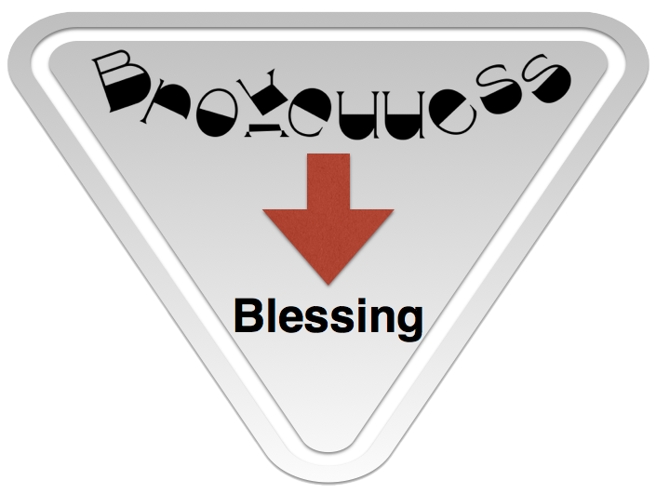
Spiritual life and growth is a process. While spiritual birth happens as an event, spiritual growth takes place over time through one’s whole lifetime. Here are some observations summarizing how many people come to new life in Christ.
  - An Intense Struggle (31:1-21)
  - Realizing God’s grace (31: 22-42)
  - Willing to make peace (31:43-55)
  - New spiritual insight (32:1-2)
  - Facing deeper conviction (32:3-12)
  - Making restoration for wrongs (32:13-23)
  - A humble meeting with God (32:24-32)
Reflective Questions for Genesis 31-32
- What is one thing you find surprising in Genesis 31-32? Why?
- How do you respond in crisis times?
- Think about Jacob’s life and his new name, Israel. Highlight the differences between a worldly seeking spirit and a biblical one.

