Oakland International Fellowship Paul J. Bucknell

The Flow: Embracing God’s Purposes for the Church (1 Peter 1:23-25)
Session #1
God actively engages in the birth and growth of His people, the church. God’s people are greatly encouraged as they better understand God’s commitment and means to help them spiritually grow. Once we know God is helping us grow, then we can eagerly focus on where He desires to take us and how He helps us get there!

The Flow
Our spiritual lives, different from religions which stress our human effort, but instead manifests God’s powerful work. The Flow describes God’s awesome way of starting a new work in an individual believer’s life and powerfully moving in the church as a whole. We need to enlarge our vision of His work by seeing how all the individual streams act as a huge confluence to form a surging river of God’s Spirit.

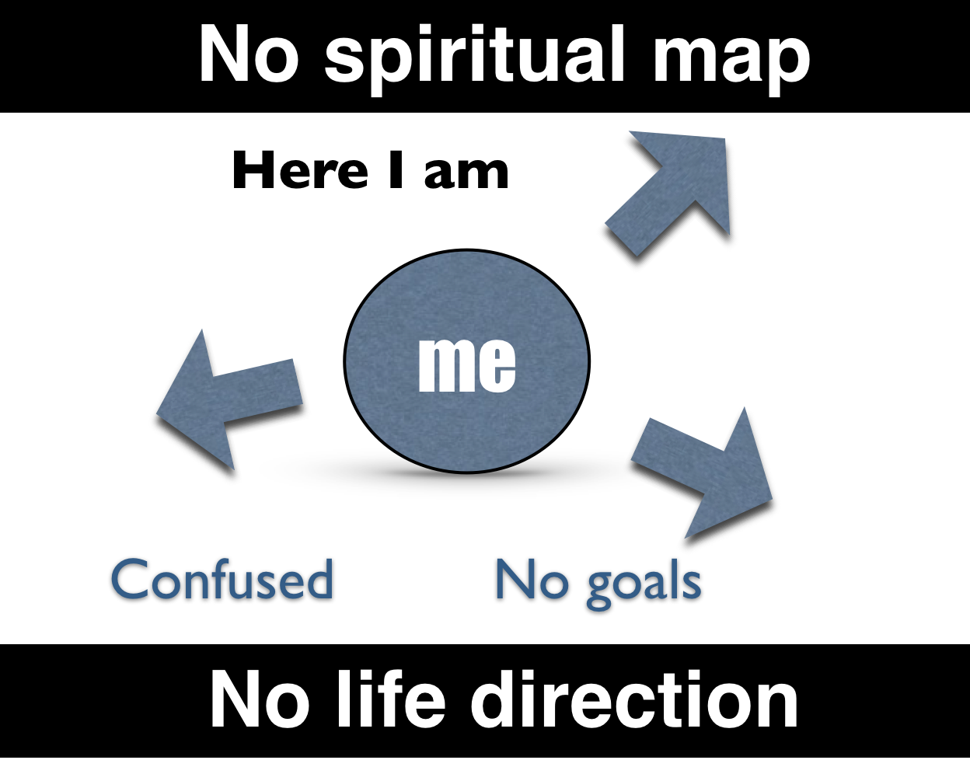
The Believers’ Confusion
Many ministers and believers focus so much getting people through the gate into eternal life that they have not considered what is beyond that point!
- Do I get stagnant in my spiritual life? Why
- What is my vision for my personal spiritual growth?

The Power of God’s Life-Giving Spirit
God’s life pours out in a constant stream.
  - A power (the ability to do something in a particular way)
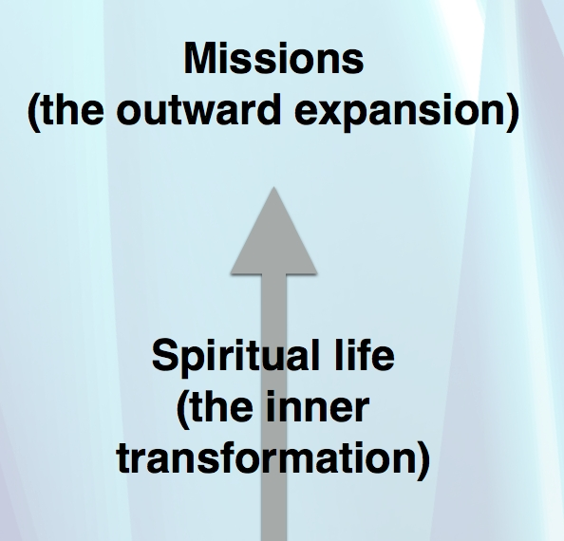
  - A direction (the course or guidance of some object)
  - A force (strength or energy from a movement)

A Mistake
Although the worldwide missions and evangelism thrust is good and necessary, we forget that the heart of its engine is the development of the people of God.
  - Missions (the outward expansion)
  - Spiritual life (the inner transformation)
Being content on evangelism without discipleship, “The church is a mile wide but only an inch deep.”

The Potential of a Seed
Born of imperishable seed (1 Peter 1:23-25)
“For you have been born again not of seed which is perishable but imperishable, that is, through the living and abiding word of God. For, ‘All flesh is like grass, and all its glory like the flower of grass. The grass withers, and the flower falls off, but the Word of the Lord abides forever.’ And this is the word which was preached to you.”
  - New life
  - Seed = Word of God
  - Living

Signs of life & death (Physically and spiritually)
LIFE | DEATH

Spiritual Life Begins!
There are two key things to know about spiritual growth to be effective in the ministry
  - Gains faith - Evangelism (John 1:12-13)
  - Grows in faith - Sanctification (Phil 1:6)

The Scriptures and Spiritual Life
Jesus and the scripture writers used analogies, including the term ‘life’,
to help us grasp and understand important truths for our Christian lives.
_________, _________, and _________
are three such analogies.
  - John 1:12-13
  - John 3:5-6
  - 2 Corinthians 3:6
  - John 4:14
  - John 10:10

Summary of Spiritual Growth
God’s life flow creates a constant upward stream from the lives of His people (Micah 4:1).
  - The seed of life
  - The force of the life-giving flow

Discussion Questions
- Why do you think believers get stagnant in their faith?
- What does the seed of faith mean? What are its implications for our spiritual lives?
- Describe a time when you got ‘caught’ in some current (e.g. air, water, etc.)? What was it like?
How is spiritual life like a current?

