Oakland International Fellowship Paul J. Bucknell

The Three Stages of Christian Life
(1 John 2:12-14)
Session #2
A comprehensive understanding of the full gamut of a Christian’s spiritual growth is gained from a biblical exposition of 1 John 2:12-14, providing insight into each of the three stages every believer is designed to experience and simultaneously answers many formerly unresolved questions about spiritual life.

Unanswered Questions
- How do Christians spiritually grow?
- Why is it that many Christians do not properly grow?
- How can I help a believer spiritually grow?
- What is the design God has for each believer’s spiritual growth?

Discoveries from 1 John 2:12-14
“I am writing to you, little children, because your sins are forgiven you for His name’s sake. I am writing to you, fathers, because you know Him who has been from the beginning. I am writing to you, young men, because you have overcome the evil one. I have written to you, children, because you know the Father. I have written to you, fathers, because you know Him who has been from the beginning. I have written to you, young men, because you are strong, and the word of God abides in you, and you have overcome the evil one” (1 John 2:12-14, NASB).
  - _____________ written
  - The three stages and meaning

The Growth Analogy
  - Power of interconnectivity
  - Spiritual growth parallels the physical growth in a family.
  - The familiar is used to describe the spiritually unfamiliar.

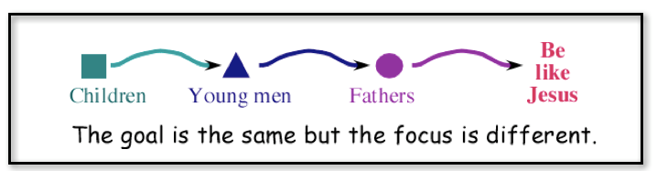

The Vision of Discipleship
The importance of Jesus’ commandment compels us to be far more thorough in our discipleship.
“And Jesus came up and spoke to them, saying, “All authority has been given to Me in heaven and on earth. “Go therefore and make disciples of all the nations, baptizing them in the name of the Father and the Son and the Holy Spirit, teaching them to observe all that I commanded you; and lo, I am with you always, even to the end of the age”” (Matthew 28:18-20).
  - Varying definitions of ‘discipleship’
  - Churches rarely carry out discipleship
  - Pastors are not typically trained to make disciples

A Chart of the Development of the Believers
The three stages of believers are situated between the two dotted lines.
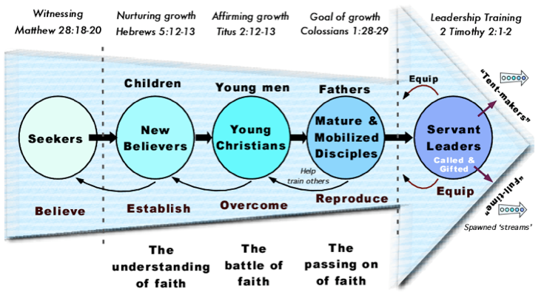
  - The Seekers (left)
  - The 3 stages between the lines produce a rightward movement of growth powered by The Flow.
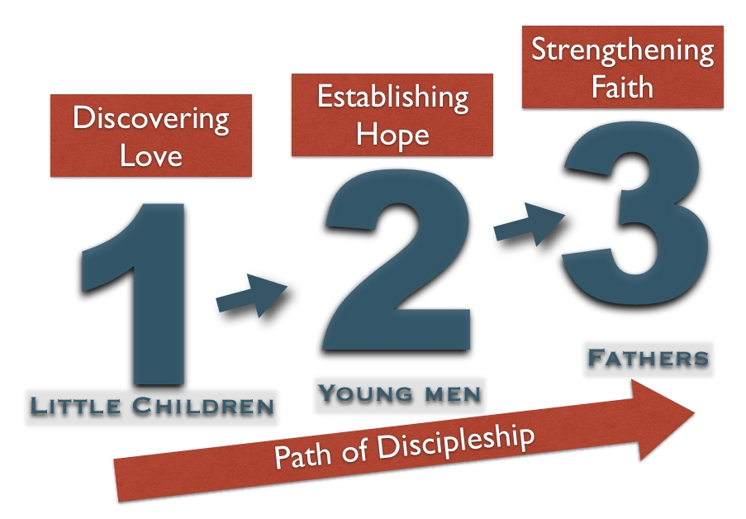
  - The Leaders (right) is a subset of the third ‘father’ stage.

Summary of Spiritual Growth
  - Growth is normal and expected.
  - Each Christian is expected to grow.
  - Greater blessings come at each stage.
  - Our service increases as we spiritually grow.
  - Answered questions (from the beginning)!

Discussion Questions
- Are you growing?
- Which stage are you at? How do you know?
- Are you helping others to grow? How so?

