Oakland International Fellowship Paul J. Bucknell

The Heart of Discipleship
(Isaiah 50:5-9)
Session #4
Isaiah 50:4-9 reveals the fifth and last critical aspect of discipleship learned from the life of Jesus: the resolve to persist doing the Father’s will. These observations of Jesus become exactly what we need to foster spiritual growth when the going gets tough. Following Jesus is a practical and dynamic force enabling us to stop focusing on our lives and delight on the opportunities that arise serving others.

Review first 4 points
We will be able to minister like Jesus when we live like Jesus. We are to imitate Him but we rarely pay close attention to how He does things. “The Lord GOD has given Me the tongue of disciples, That I may know how to sustain the weary one with a word. He awakens Me morning by morning, He awakens My ear to listen as a disciple.”
  - A.) The ____________ of the Disciple (Isaiah 50:4a)
A disciple is a learner. The best teacher is the best learner!
  - B.) The ____________ of the Disciple (Isaiah 50:4b)
A disciple serves others. Learning is only valuable when we have hearts to serve!
  - C.) The ____________ of the Disciple (Isaiah 50:4c)
A disciple early each day communes with God. God desires to encounter His people each and every day.
  - D.) The ____________ of the Disciple (Isaiah 50:4d)
A disciple attentively listens to and obeys God. Our humble and submissive attitude enables us to listen.

Summary
  - Our humble and submissive attitude enables us to listen. We need to up our expectations of what the Spirit of Christ can do by living in us. We, like Jesus, can be empowered to seek and accomplish the Father’s will by the abounding grace of God.

E.) The Resolve of the Disciple (Isaiah 50:5-9)
A disciple withstands difficulties to please His Master.
“He who vindicates Me is near; Who will contend with Me? Let us stand up to each other; Who has a case against Me? Let him draw near to Me. (9) Behold, the Lord GOD helps Me; Who is he who condemns Me? Behold, they will all wear out like a garment; The moth will eat them” (Isaiah 50:5-9).
The fifth point comes from Isaiah 50:5-9, enabling us to trust in the Lord when being severely tested. Learn to endure difficult trials in four ways.

1. Our Heart Commitment (50:5)
“The Lord GOD has opened My ear; and I was not disobedient, nor did I turn back” (Isaiah 50:5).
    - Awakening (4 “He awakens My ear to listen as a disciple.”) differs from opening the ear (5)
    - God Yahweh breaks the door of resistance.
“And he who does not take his cross and follow after Me is not worthy of Me” (Matthew 10:38).
    - Our ___________ need changing
    - Testimony - The _______________

2. Our Choice to Serve (50:6)
“I gave My back to those who strike Me, And My cheeks to those who pluck out the beard; I did not cover My face from humiliation and spitting” (Isaiah 50:6).
    - “I” – _________ choice not His enemies (John 19:10-11).
    - “I gave My back” – ___________ is in control
    - “I did not cover My face” – He was not ashamed but bold on serving His Father’s will.

3. Our Trust in God (50:7)
“For the Lord GOD helps Me, therefore, I am not disgraced; therefore, I have set My face like flint, and I know that I shall not be ashamed” (Isaiah 50:7).
    - Not a __________ of pain
    - “The Lord God helps Me” - God’s sufficient ___________
    - “And He has said to me, ‘My grace is sufficient for you, for power is perfected in weakness.’ Most gladly, therefore, I will rather boast about my weaknesses, that the power of Christ may dwell in me” (2 Corinthians 12:9).
    - Accepts our weakness, pain, and trials

4. Our Victory over ________________ (50:8-9)
“He who vindicates Me is near; Who will contend with Me? Let us stand up to each other; Who has a case against Me? Let him draw near to Me. (9) Behold, the Lord GOD helps Me; Who is he who condemns Me? Behold, they will all wear out like a garment; The moth will eat them” (Isaiah 50:8-9).
Bitterness must be overcome if we are going to faithfully follow Jesus’ example. Satan uses bitterness in our hearts to block God’s grace. If we do not forgive, the Lord says He will not forgive us (Matthew 6:14-15).
    - Note blind to injustice
    - God will faithfully judge. We do not seek ___________ (Rom 12:19).
    - Persecution does not necessarily mean that we deserve judgment.
    - God’s judgment is coming soon. The wicked will be soon destroyed.

Summary of Spiritual Growth
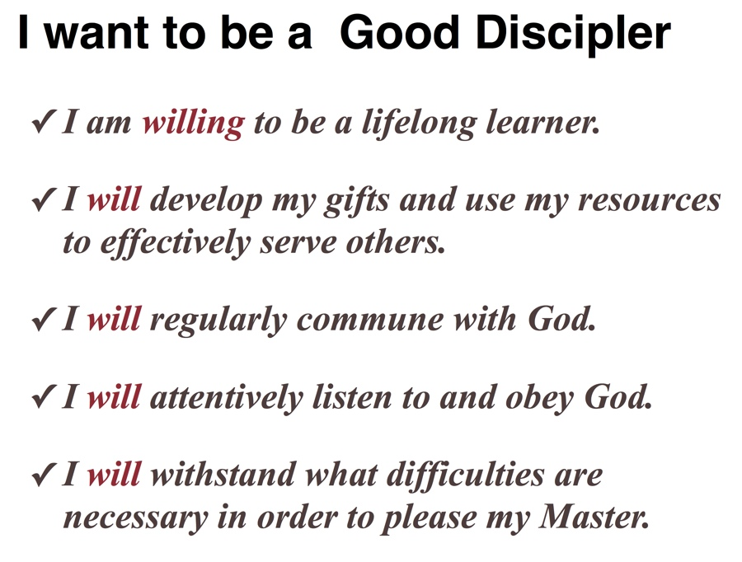
There is no greater goal for our lives than to be like Jesus. We need to imitate the way He communed with the Father, cared for others, and gained wisdom, stamina, and compassion for what He needed to do.

Discussion Questions
- How do you respond if you do not like what your Heavenly Father asks you to do?
- What is so wrong with bitterness?
Is there someone you haven’t forgiven?
- How did Jesus demonstrate the trouble with having a victim mentality? How can believers fight against these waves of negativity that sometimes spring upon us?

