Oakland International Fellowship Paul Bucknell / Raymond Breckenridge Orr
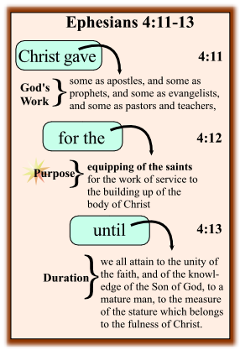
God’s Design of the Church (Session #11)

Paul, having clearly elaborated on the salvation of the church in Eph. 1-2, now presents us with the reason Jesus died. God is creating a people from all the nations, to follow Christ’s example of wholly loving, trusting and serving Him. Paul desires this truth to seep deep into the church’s soul.

Ephesians 4:11-13 is a passage that enables us to understand what God has done for the church in Christ by His saving her, and what He saved her for.
How have you experienced the life of the church?
- Some participants in the visible church have great expectations and joy, while others may feel disappointed or hurt by past experiences.

What makes the church strong or weak?
- What we think and understand about the church greatly influences what shape the church will take.

- Godʼs Work: How does God help the church (4:11)
And He gave some to be apostles; and some, prophets; and some, evangelists; and some, pastors and teachers.
- Each believer has a God-designed calling (vocation)
- Some believers are set aside for specific kinds of service. Their gifts cover everything necessary for Christ’s body to thrive.
- God is the divine Giver of every good gift!

Conclusion: It is clear that God calls some for special service; set apart by gifting and training.

- Godʼs Purpose: What is Godʼs purpose for this? (4:12)
For the perfecting of the saints, unto the work of ministering, unto the building up of the body of Christ.
- Each believer has a need to be equipped
- The saints are equipped as each one fulfills their responsibility to serve, to minister and to build one another up.
- Christʼs Spirit living in and through His people brings this to pass. We are to keep in focus that such work is first and foremost a privilege.

Conclusion: God enables all His people to serve, equipping everyone, but our effectiveness depends on how we do this together as one body.

- Godʼs Expectations: What does God expect from the church? (4:13)
Until we all attain to the unity of the faith, and of the knowledge of the Son of God, to a mature man, to the measure of the stature which belongs to the fullness of Christ.
- Believers are to form a community that collectively lives life in the world according to Godʼs Word.
- The church is to grow in unity of the faith, as we embrace a true knowledge of the Son of God.
- The church is called to mature into the fullness of Christ, to do the will of God, bringing Him glory and eternal gratitude.

Conclusion: God desires the whole body to mature as we grow in living out the ‘fullness of Christ’. As we do, God’s divine glory is revealed.

- Godʼs Design of the Church
The church was fully established when God the Father sent His only begotten Son Jesus Christ into the world. He is the authoritative ‘Head’ of the church.
God breathes life into the church and manifests His life through the church as the Holy Spirit empowers and sends out God’s people to live in obedience to His Word.
Spiritual gifts that God gave to the church (eg.Eph.4:11-13) are dispensed generously among believers for the purpose of training and building up the whole body of Christ.
In Summary:
- It is clear that God calls some for special service; set apart by gifting and training.
- God enables / empowers all His people to serve, equipping one-another so that we may grow / mature in the fullness of Christ, according to His will and for His glory.
- Every Christian is to be engaged to some measure in this great responsibility, this divine privilege.

Discussion Questions:

✦ Has God called you to equip others for service and are you being faithful to that calling?
✦ Where are you serving now to build up the body in the fullness of Christ?
✦ Do you sense God’s joy as you help others grow in unity of faith, the knowledge of the Son of God and maturity in Christ?

