Oakland International Fellowship Paul J. Bucknell

Growing in Our Life Purpose

Philippians 3:12-14
Session #16
Life purpose is the underlying confidence and direction for which God _____________ made us. This understanding develops as we spiritually grow, providing clarity to the question, “Why did God make me?”
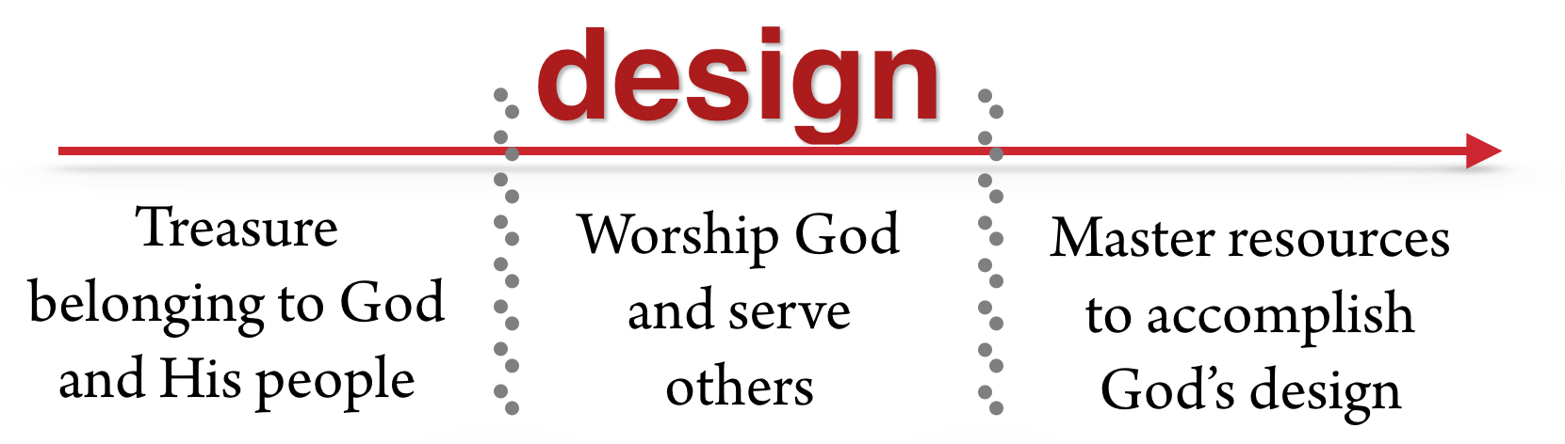
- Level 1 - Treasure Belonging to God and His People
People do not expect a toddler to understand his or her life purpose nor do they expect a new believer to understand their life purpose. New believers do not understand their purpose for their new lives but instead are amazed by the glory of being God’s children–accepted in Christ, being wonderfully loved by Him.
Life Purpose
“But as many as received Him, to them He gave the right to become children of God, even to those who believe in His name” (John 1:12).
“See how great a love the Father has bestowed upon us, that we should be called children of God; and such we are. For this reason the world does not know us, because it did not know Him” (1 John 3:1).

New Believer’s Growing Purpose
- Excitement about belonging to God when becoming a Christian
- Love being with God’s people
- Disdain for one’s old ways and instead desire to please the Lord
- A few are given a call to missionary or pastoral service

New Believer’s Hindrances
- Don’t regularly go to a church (and learn of God’s love)
- Don’t know the Father’s ability to care for them in their life walk
- Get too busy to fit into a small group with other believers
- Feel so guilty that they avoid God and the church

Focus on _______________ rather than the _______________ _______________
God is quite content for the new believer to be focused on growing a lot in their spiritual lives, absorbing the love of God, and establishing their security in the love of God.
_______________ precedes _______________; life and energy come before purpose.
- Level 2 - Worship God and Serve Others
Young believers are learning how to overcome temptation and respond in _____________ to God’s general commands and calling. Jesus the head works in His members to carry out His will.
“By this we know that we love the children of God, when we love God and observe His commandments. For this is the love of God, that we keep His commandments; and His commandments are not burdensome” (1 John 5:2-3).
“…God has placed the members, each one of them, in the body, just as He desired” (1 Cor 12:18).

Young Believer’s Growing Purpose
- Relationships: How do I love those that I don’t get along with?
- Worship: Exalting the Lord with His people is one of my greatest delights.
- Service: I am learning how all work is holy to God, even tasks that others shun to do.
- Uniqueness: I am learning about spiritual gift(s).
- Prioritization: I deliberately shape what I do so I can better use my life to help others.
As the believer grows, he or she becomes increasingly aware of God’s expectations for his/her life and the need to obey the Lord. Obedience is based on faith and so precedes complete understanding. “I do it because He wants me to.”
- Level 3 - Master Resources to Accomplish God’s Design
As believers mature, they are increasingly aware of their unique design and try to grasp God’s rich purposes for their lives and so seek to fulfill them.
“Not that I have already obtained it, or have already become perfect, but I press on in order that I may lay hold of that for which also I was laid hold of by Christ Jesus. Brethren, I do not regard myself as having laid hold of it yet; but one thing I do: forgetting what lies behind and reaching forward to what lies ahead, I press on toward the goal for the prize of the upward call of God…” (Phil 3:12-14).
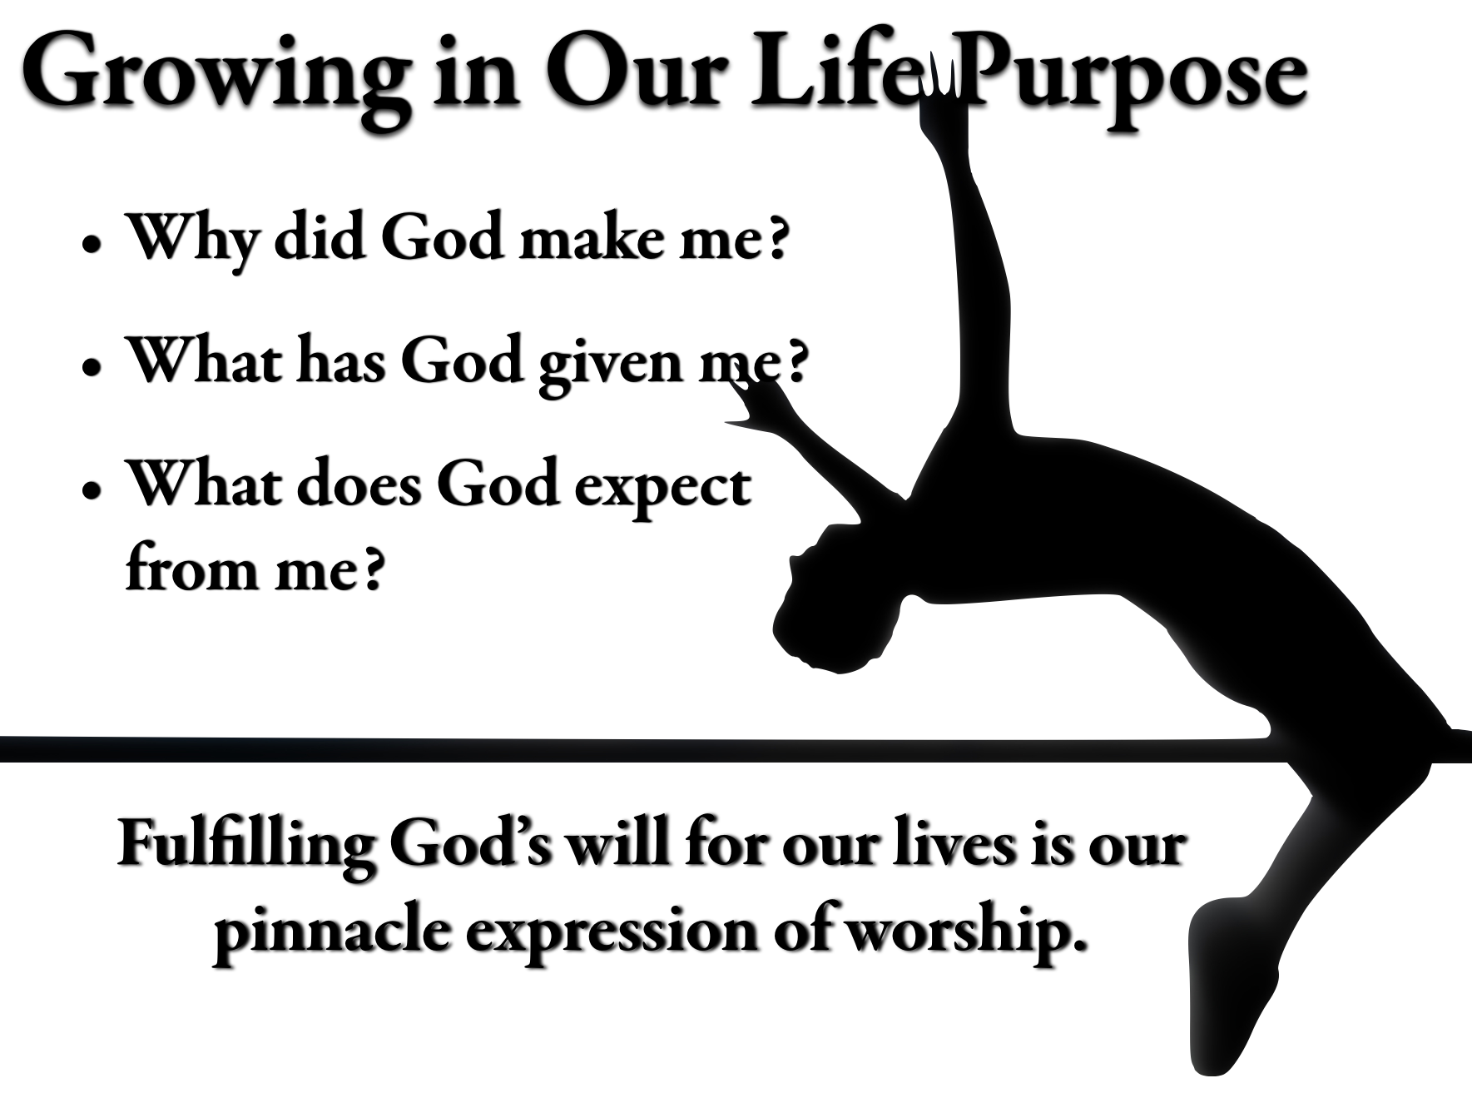
“For we are His workmanship, created in Christ Jesus for good works, which God prepared beforehand, that we should walk in them” (Eph 2:10).

Mature Believer’s Growing Purpose
- Takes a spiritual gift survey and use my spiritual gift(s).
- Become quite committed to the local church where I attend.
- Makes opportunities to build up believers in their faith.
- Tells the Lord, “I am open to whatever you want for my life.”
- Spend extra time with the Lord in prayer and the Word trying to get to know Him and His will for me.
- Though not fully knowing God’s future for my life, I am confident of God’s presence and guidance.
- Confident that the Lord will provide all that I need to effectively serve Him.
The key is not in ourselves but completing God’s specially designed “________ ________” through our lives.
Summary: The inpouring of God’s love never stops, eliciting trust in God’s will for our lives and creating excitement and drive to fulfill God’s purposes.

Questions
- What are some things that hinder you from focusing on God’s purpose for your life?
- Where are you in your ability to understand God’s full plan for your lives (refer to diagrams)?
- Identify one of the vision statements above that helps you understand God’s work in your life, helping you realize your life purpose.

