
Oakland International Fellowship Paul J. Bucknell

The Path of the Spirit (Gal 5:25)
Section 1: Christian Beginnings – #1 Handout
Christians are designed to regularly experience the presence and empowering of the Holy Spirit and like Jesus to constantly rely on Him for their spiritual life and service. But what is the Holy Spirit? How does one learn about Him and rely on Him? How does He lead us? This series navigates us in an exciting journey of biblical learning on the Holy Spirit so that we might constantly walk fully affected by the Spirit’s presence and power.
“If we live by the Spirit, let us also walk by the Spirit” (Gal 5:25).


A) Defining the Spirit
- The words “Spirit” and “spirit” in the Bible need to be distinguished:
Capital (‘S’) refers to God Himself while small (‘s’) describes a person’s mood or inner being. This word is used 519 times in the Bible, 200 (80 of God) times in OT and 319 (223 of God) times in NT.
- Exercise #1: There was no differentiation between small letters and capitals in the original language. The meaning is determined by the context. Circle each ‘spirit’ that should be capitalized because it refers to God (Spirit) and underline the correct ones (with a small ‘s’).

B) Detecting the Path of the Spirit
“And the earth was formless and void, and darkness was over the surface of the deep; and the Spirit of God was moving over the surface of the waters” (Gen 1:2).
- “Spirit of God” (2): The ‘Spirit of God’ is first referred to as the 16th word in the Hebrew Bible. From this verse onwards we wonder, “Who is the Spirit of God and what is He doing?” This verse reminds us that this world is comprised by more than atoms and molecules, and that the Spirit plays a crucial role in the universe.
- “Spirit of God” (2): At times the Spirit of God is set against the evil spirit, “The Spirit of the LORD departed from Saul, and an evil spirit from the LORD terrorized him” (1 Sam 16:14-15).
- Many times ‘spirit’ (small ‘s’) refers to a person’s inner being including the soul, the part that cannot be touched, “and he ate; then his spirit revived” (1 Sam 30:12).
“Now we have received, not the spirit of the world, but the Spirit who is from God, that we might know the things freely given to us by God” (1Co 2:12).
- “We have received” (1 Co 2:12) shows how we are to be greatly influenced by the Holy Spirit,
- “Received…the Spirit who is from God” teaches us how believers are to be intimately acquainted with God, “But the one who joins himself to the Lord is one spirit with Him” (1 Co 6:17). (‘S’) or (‘s’) here?
Summary: We should anticipate for God the Spirit to powerfully work in our lives.

C) Confusion Over False spirits
“Beloved, do not believe every spirit, but test the spirits to see whether they are from God; because many false prophets have gone out into the world” (1 Jo 4:1).
- Command #1: “Do not believe every spirit” cautions us not to trust any spirit. We need discernment to evaluate the spirits out there. What spirits are out there? (e.g. yoga)
- Command #2: “Test the spirits” is the second command instructing us to complement our caution with real testing. Evidently, we cannot trust others to guard us and need to advance to the level where we can discern between bad spirits and the Holy Spirit. Learning about the Holy Spirit, then, is a basic skill for the believer.
- Explanation: “Many false prophets have gone out into the world” shows us why we are to be cautious. Just as the Holy Spirit proceeds from God, so false spirits are issued from the evil one, accompanying false prophets. Is every false teaching sponsored by one or more false spirits?
Summary
The evil one does everything to keep God’s children from walking in the fullness of the Spirit. He greatly fears ‘little’ Christs (literal definition of ‘Christians’) flooding the earth! We do not fear the Spirit but greatly desire His companionship, knowing that it is only God’s growing kingdom which brings salvation, joy, and love to this world.

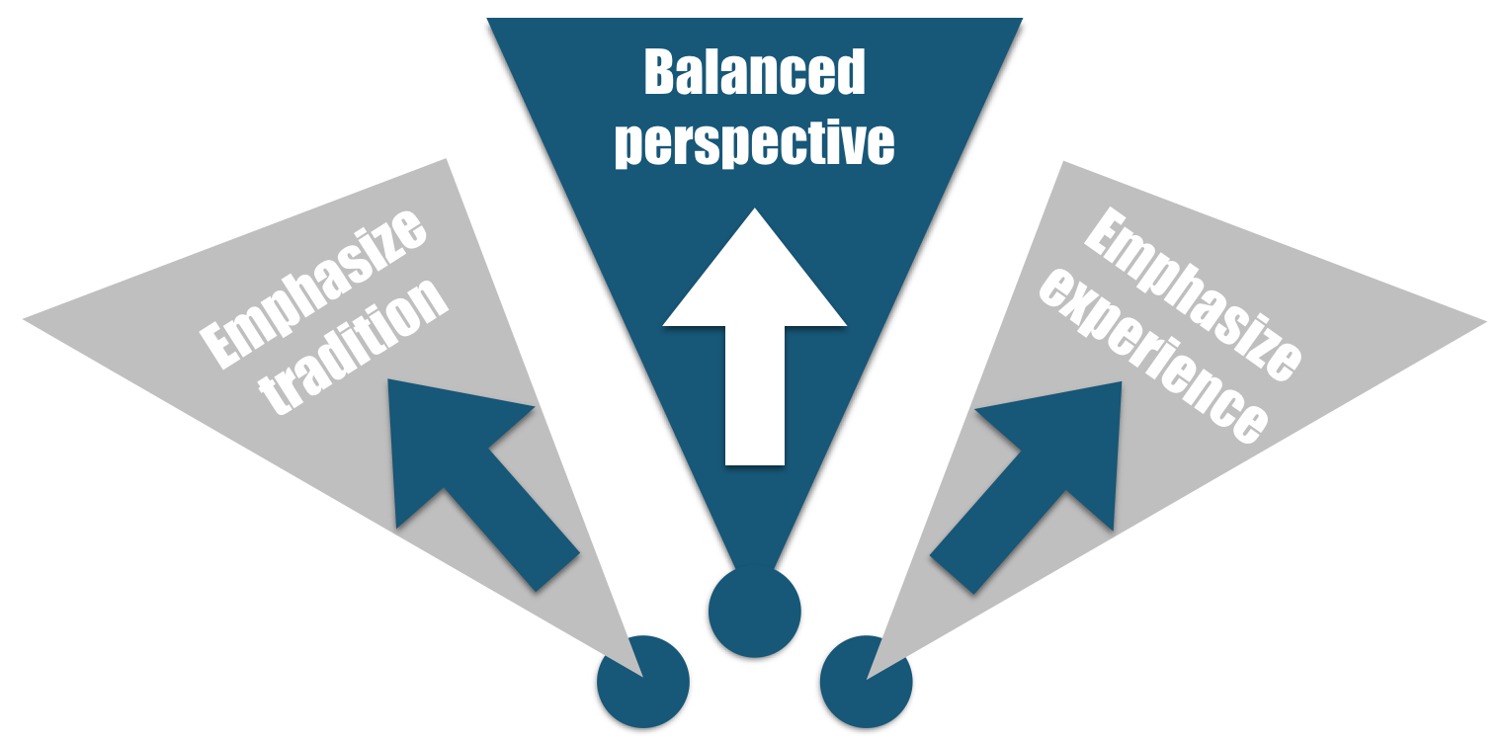
D) Understanding Our Differing Beliefs of God’s Spirit
“There is one body and one Spirit” (Eph 4:4).
Each believer has grown up with varying influence from one or more Christian traditions, even if the church claims not to be a traditional! What kind of situation were you spiritual born or grown up in? One’s setting forms one’s mindset. Most Christians unknowingly evaluate their approach from experience and not scripture.
- “One Spirit”: Though there be many experiences and understandings among God’s people, there remains to be one Spirit.
- “One body” shows us the need for God’s people to live in harmony, learning from each other but not removing our discernment.
- What do you understand of the Holy Spirit?
- Exercise #2: These Bible verses highlight the various activities of the Spirit of God. After each verse on the left, write down on the right a verb(s) describing what the action of the Holy Spirit is in your own words.

E) Living by the Spirit
“If we live by the Spirit, let us also walk by the Spirit” (Gal 5:25).
- “Live by the Spirit” indicates that the Spirit of God is intricately involved in our lives and that many aspects of our lives are enhanced by the Spirit of God.
- “If we…, let us…” suggests that though the Christian is offered success, there are ways to not “walk by the Spirit” resulting in loosing many benefits.
- “Walk” infers learning takes place each step of our daily walk.
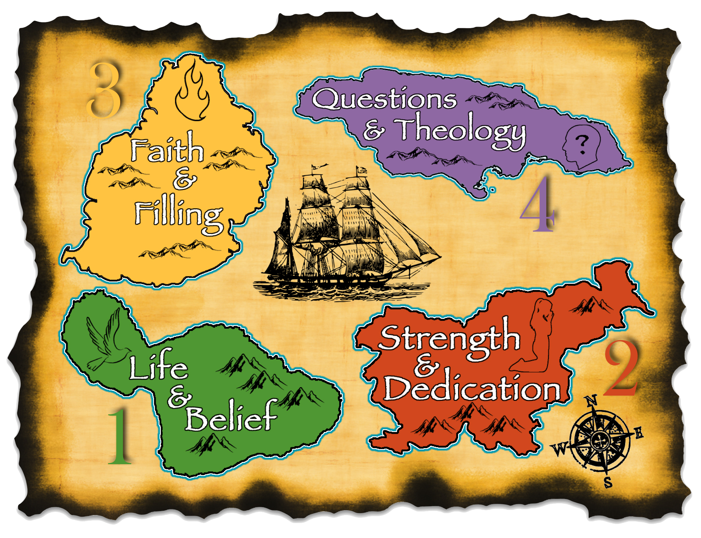
- “By the Spirit” reminds us that we are not experts but humbly learning from the Spirit.
Summary: Be attentive to how the Spirit teaches you to rightly respond to Him, people, yourself and situations.

Conclusion: Experiencing the Fullness of Christ
Our hope is to have the Spirit fill us so that Christ can live out His purposes through our lives for His glory and the benefit of others around us.
Our goal is to remain on the most optimum path, being sensitive to the Holy Spirit’s leading, finding extra faith and knowledge as we go along. May the Holy Spirit help us maximize our lives so that we can follow the path that Jesus sets before us each day!

Discussion Questions
- What is one thing you learned about the Holy Spirit from these two exercises?
- Why is it important to “test the spirits”? What spirit seems to trouble you the most?
- What is one thing you learned when a young believer regarding the Holy Spirit that has positively or negatively affected you to this day?

