
Oakland International Fellowship Paul J. Bucknell

The Network of the Spirit (1 Cor 2:10-16)
Section 1: Christian Beginnings – #2 Handout
What is spirituality? For many spirituality means connected to whatever is out there (Eph 2:2), but for believers spirituality means that a person can now through the Spirit and Christ’s work marvelously know God and discover what He wants for their lives.
“The thoughts of God no one knows except the Spirit of God.”


A) The Natures of Man and God (1 Cor 2:11)
“For who among men knows the thoughts of a man except the spirit of the man, which is in him? Even so the thoughts of God no one knows except the Spirit of God” (1 Cor 2:11; NASB)
- “Knows man” and “God” is the literal Greek (no “thoughts of”). Whether a human or God, one’s real person is signified by one’s thoughts hidden from others.
- “The spirit of the man” refers to the inner person and uses ‘spirit’ (pneuma) to identify that mysterious invisible network between the soul, mind and thoughts (i.e. self-awareness).
- Exercise: Think of a compliment for a person. Note how it is hidden in your mind, then write it down or share it! Words express your inner person and makes what is hidden public.
- “Spirit of God” describes God’s person, full awareness of His thoughts and will.
- The original Greek for the words “spirit” and “Spirit” are the same, emphasizing the commonality of the networking. People can share their thoughts and communicate because their networks can join up.


- The phrase “Except the Spirit of God” intimates that the human race no longer ‘naturally’ communes with God and needs the Spirit of God to know and relate to God.
- “No one knows except the Spirit of God” declares man’s lockout from God. Without knowing God’s thoughts we cannot know God, and without the Spirit (and Jesus), we cannot connect. Man is spiritually dead (Eph 2:1-2).
- This brokenness explains the ‘natural’ animosity of the world (us) against God (Ro 3:23;8:6-8) and that what once was can be restored through Christ linking God and man.
Summary: People have a spirit but no longer are naturally spiritual since they do not know God or have the Spirit to commune with God. A person can share his thoughts, truthfully or falsely, with others (e.g. Facebook).

B) The Knowledge of God (1 Cor 2:10-12)
“10 For to us God revealed them through the Spirit; for the Spirit searches all things, even the depths of God. 11 For who among men knows the thoughts of a man except the spirit of the man, which is in him? Now we have received, not the spirit of the world, but the Spirit who is from God, that we might know the things freely given to us by God” (1 Cor 2:10-12).
- “The Spirit searches all things” (10) reveals the Spirit knows the inner thoughts of human beings and “even the depths of God” (from simple to complex). Example: Sarah’s hidden laugh is discovered (Gen 18:13-15).
- “For to us God revealed them” (10) identifies how God reveals His thoughts with a select group–“to us”.
- “Have received…the Spirit who is from God” (12) reveals the basis of the spiritual network intertwining man’s thoughts with God’s. God has caused us to know Him through the Spirit.
- “The Spirit who is from God” (12) is not a computer search robot nor a force but an extension from God implying relationship. Spiritual networking is more than a mere network but includes relationship with God.
- The spiritual network includes not just man’s thoughts but always intertwines God’s thoughts with man’s. God has caused us to know Him through the Spirit.
Summary: True spirituality, then, is not only being known of God which is true of all people but knowing God through the Spirit. God has powerfully reinstituted the spiritual network in Christ that we had lost through Adam’s fall. The disconnect between God and man serves as a pointer to what once was and now can again be initiated and sustained through Christ and the Spirit–a renewed spiritual network where God and man are linked together evidenced by prayer and biblical meditation.

C) The Natural Versus the Spiritual (1 Cor 2:14-16)
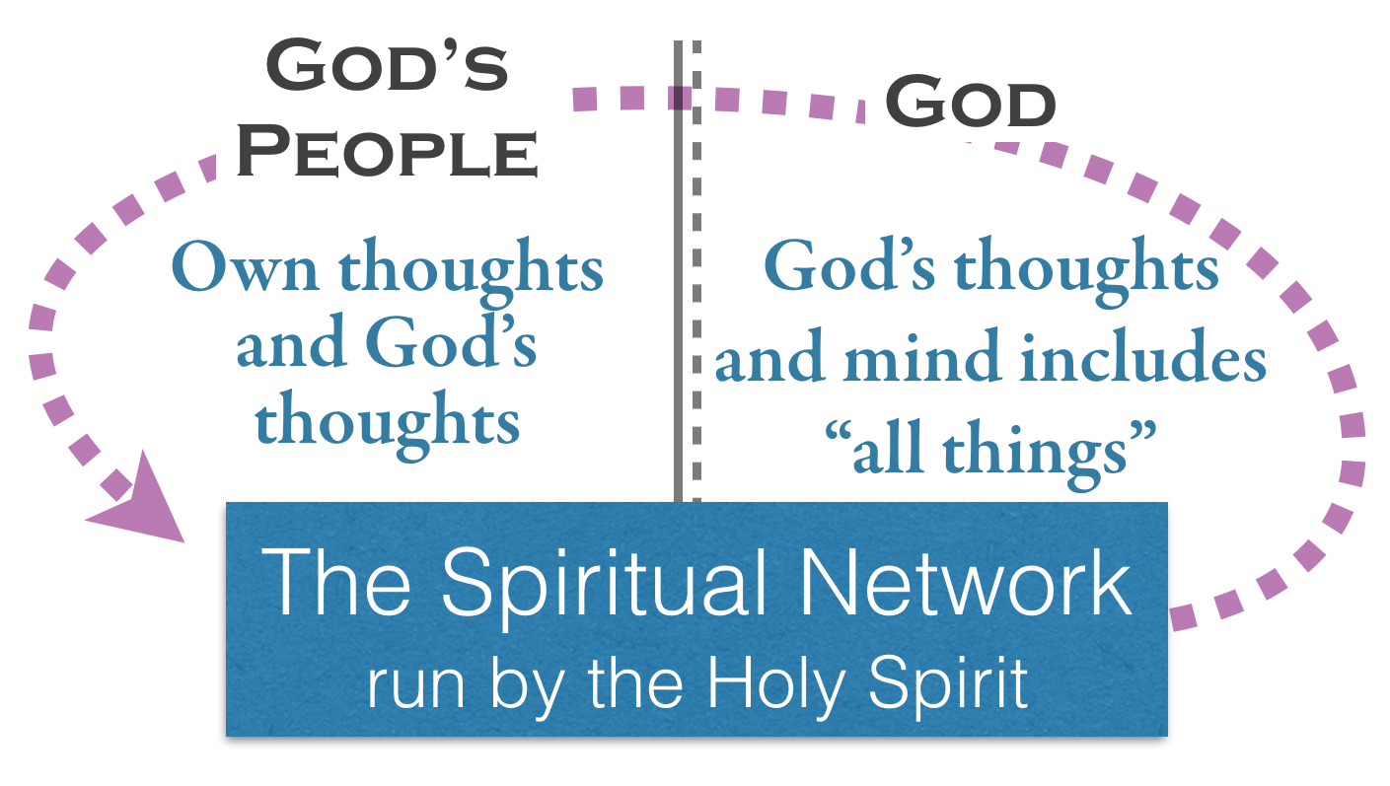
“But a natural man does not accept the things of the Spirit of God; for they are foolishness to him, and he cannot understand them, because they are spiritually appraised. 15 But he who is spiritual appraises all things, yet he himself is appraised by no man. 16 For who has known the mind of the Lord, that he should instruct Him? But we have the mind of Christ” (1 Cor 2:14-16).
Natural Man | Spiritual Man
“Does not accept the things of the Spirit of God” (14) | “But he who is spiritual” (15) describes the believer in Christ having the Spirit.
“Things of the Spirit…are foolishness to him” (14). | “Appraises all things” (15) refers to his ability to know the things God has told him.
“He cannot understand” the ‘things of the Spirit’ (14). | “But we have the mind of Christ” (16).
“They are spiritually appraised” (14). | “For who has known” reminds us that we are humbled we only know what God reveals (16).
By sending His Spirit to be integrated in our lives through Christ, we can now know what God reveals to us. Before we were spiritually impaired but in Christ made new! We now have the mind of Christ.

Final Summary
- All people have a ‘spirit’ network which cannot apart from God’s work connect to God–natural man.
- True spirituality (only God’s people) describe those who have received the Spirit of God enabling them to have the mind of Christ.
- As believers we are potentially able to know all we need from God (includes warning, encouragement, knowledge, etc.) to live out God’s will for our lives–as Christ fully did.
- Satan will attempt to hack this spiritual network, blocking God’s signal by getting us to listen to him.
- Faith describes those truths that we know through God revealing them through the Spirit.

Discussion Questions
- Can’t we learn things about God without the Holy Spirit? Explain in light of the verses above.
- Do you want to be connected to God, people or the web more? Why?
- What are the things that tend to interfere with either God speaking to you or you with God?

