
Oakland International Fellowship 2.14.2016 Pastor Hugo Cheng

6) The Leading of the Spirit
Section 2: Christian Growth- Strength & Dedication
Seeking God’s will is an ongoing special interest topic for believers. The assumption is that God through the Holy Spirit gets involved in minute aspects of our decision making, giving us great help in leading a wise life filled with His blessings. It certainly makes sense that we believers as the children of God who are designed by God would seek His wisdom for the kind of life we should live, but the leading of the Holy Spirit can come in different forms- which includes moral and spiritual guidance to help us live a life of faith and obedience in Christ, the specific personal leading of our directions for life, and wisdom and grace for us to make decisions in freedom and peace. We need to learn and grow in how to discern and follow His leading.

A) The Certainty and Variety of The Spirit's Leading
- God's promise of His leading: Proverbs 3:5-6, Psalm 23:1-3, John 10:27
- In what areas does the Holy Spirit actually lead us? There are a few overlapping categories:
  - Moral Guidance & Empowerment
  - Understanding of God's Truth
  - General Life Direction & Decision
Which type of leading of the Spirit are these?
- Galatians 5:16-23 “Led by the Spirit” shows that the Holy Spirit takes an active part in the Christian life. The Spirit is not just around the believer but directs and empowers him/her to live a life that reflects the godly character of Jesus Christ, even in the midst of struggling with our old sinful self ("flesh"). “Not under the Law” opens our understanding that our faith is not about following a set of religious laws but rather a living relationship of trust and dependence on God's Spirit.
- 2Corinthians 3:17-18. The Holy Spirit sets us free from the bondage of sin and the burden of dead religious regulations. He empowers us and transforms us into the likeness of Jesus!
- Ephesians 5:15-21. The Holy Spirit "fills" us so that we are under His leading/influence to live a life of worship, thanksgiving, and love.
- Romans 8:13-16. The Holy Spirit not only empowers us to have victory over sin, He also reassures us of the intimate relationship we have with God as our Father.
- John 16:13, 14:26. There is a twofold teaching ministry of the Holy Spirit- a. New truths: “He will teach you all things” unleashes any limits that might limit what the Holy Spirit might need to state to us. b. “Bring to your remembrance all that I said to you” can be used not only of words Jesus said to the disciples but the truths from the Word of God that God has formerly taught us.
- Matthew 4:1, Luke 4:1, Acts 13:2, 16:6-7. The Holy Spirit at times also gives specific directives to what we are to do and not to do in life's direction and decisions. Yet at other times, He delights to provide us wisdom and grace for us to decide in faith and freedom.
Summary: Jesus might not be here with us physically, but with the Holy Spirit in us, Jesus is with us all the time through Him (John 14:16-20), He is here to help us to succeed in our life of faith.

B) Resisting The Spirit's Leading
- 1Thessalonians 5:19. It is possible for us to ignore and resist the leading of the Spirit and chose to act or not act according to our own desires. This will quench the Spirit's leading and hinder our relationship with God. If we persist in this direction, it will make it harder and harder to sense the leading of the Spirit.
- Ephesians 4:30. Because the Holy Spirit loves us as God the Father and Jesus love us, we can actually grieve (caused sadness) Him when we chose to disregard His leading and sin, especially against other Christians whom He has placed us together to be one community and one body of Jesus Christ(1Cor. 12:12-13).

C) Accessing & Experiencing the Spirit's Leading
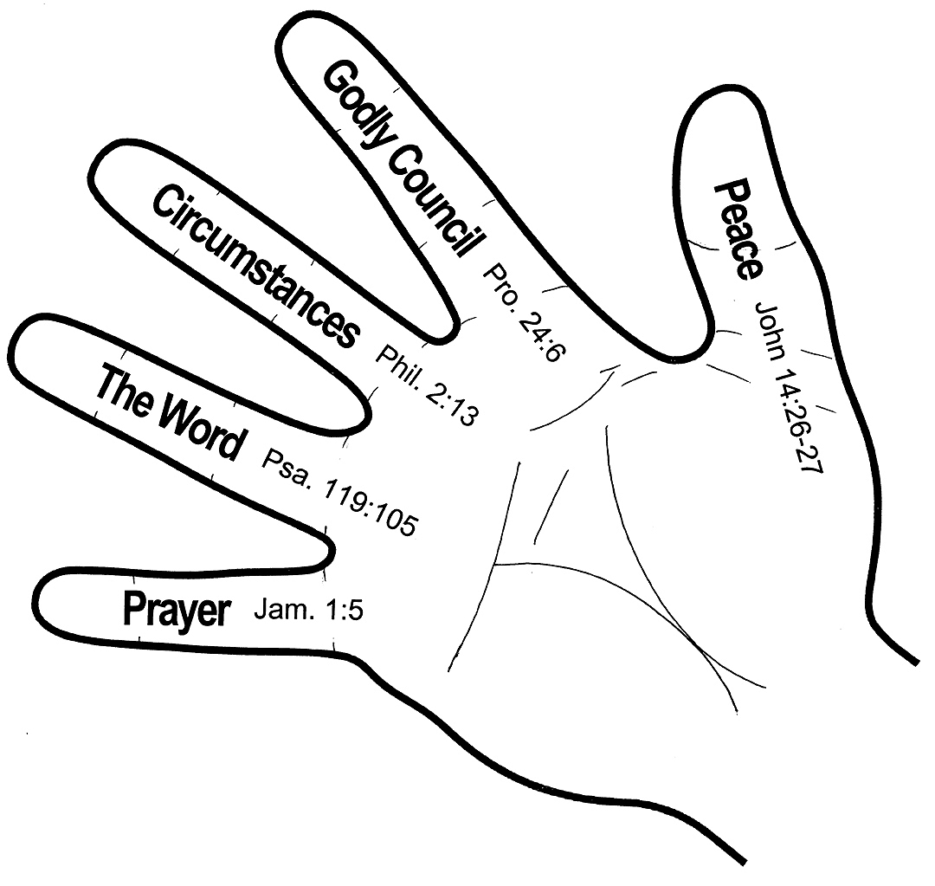
- There are many "tools" given by God for us to discern His will. The Holy Spirit can use each one of them to guide us. We must proactively partner with Him in using these tools by faith.
- When discerning the will of God, we need to be mindful of His sovereign, moral, and personal will, then discern and follow His will in faith by grace.
Jesus is Lord!
Matt. 11:28-30
John 10:27
Romans 12:1-2
Proverbs 3:5-6
God's sovereign will
God's moral will
God's personal will
Specific directive or
Freedom in wisdom and grace

Final Summary: The Holy Spirit's purpose and desire is to be active in the believer's life. He leads us in the understanding and applications of God's Word. He empowers us to grow in Christ-likeness. He convicts us when we sin. At times He gives us specific directives in life's decisions, and at other times He provides us wisdom to make the decisions.

Discussion Questions
- Have you ever experienced the guidance of the Holy Spirit? Please share.
- Are there currently any areas in your life where you are trying to discern the leading of the Spirit? Pray for one another.

