
Oakland International Fellowship Paul J. Bucknell

#14 Gifts of the Holy Spirit (2) (1 Cor 12:1-7)
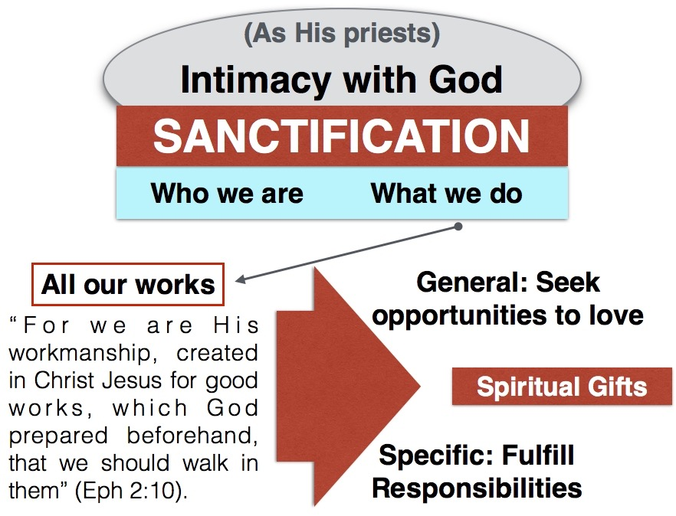
Section 3: Faith and Filling Handout
Jesus’ disciples are committed to proclaiming the Gospel. So why is there so much disagreement over how God’s Spirit works? Admittedly, there are false prophets who discredit the gospel with their lives and a false gospel, but the scriptures show us how the Spirit mobilizes God’s people and sets them in motion as a big team with the same gospel mission–no matter our differences.

The Gifts of the Holy Spirit (1 Cor 12:1,4-7)
“1 Now concerning spiritual gifts, brethren, I do not want you to be unaware. 4 Now there are varieties of gifts, but the same Spirit. 5 And there are varieties of ministries, and the same Lord. 6 And there are varieties of effects, but the same God who works all things in all persons. 7 But to each one is given the manifestation of the Spirit for the common good” (1 Cor 12:1,4-7).
- “Spiritual gifts” (1) (lit. ‘spiritual things’) emphasize the special imparting of skill, wisdom, speech, miraculous power, etc. by God through the Holy Spirit to equip His people to carry out His service. By being labeled ‘spiritual’, all spiritual gifts (clarified by the ‘gifts’ in verse 4) are Spirit-given and by nature divinely empowered and purposed.
- “Gifts, but the same Spirit” (4) (literally charismata–root for charisma, charismatic) supplies the description in verse 12:1 as in 1 Cor 14:1,12. The root ‘charis’ means grace or divine gift and reminds us not only of the source of power to be God but the fact it is undeserving (grace) and never should become a point of pride. The phrase “spiritual gifts” is not used in the scriptures but appears to be the proper translation (also Rom 1:11; 1 Tim 4:14).

- “Do not want you to be unaware” (1) reflects problems in a believer’s knowledge about spiritual matters: They (1) have misunderstandings and (2) doubts. The diagram shows some sources for wrong ideas.
  - Stage #1 Unaware: Every believer receives a spiritual gift but doesn’t grasp its potential.
  - Stage #2 Discovery: Each believer grows through stages of immaturity where, because of a lack of perspective, pride can enter by overemphasizing one’s confidence in theology, communion with or zeal for God, or possession of gifts.
  - Stage #3 Usage: Upon maturity, a believer (i.e. father)
will value every believer’s gifts and humbly encourage
each to faithful service by their own example and instruction.
- “The same Lord” (5) and “the same God” affirms God is completely in charge of the distributed spiritual gifts. Interestingly, He deems it wise to work through His people like us to accomplish His divine work.
- “God who works all things in all persons” (6): People do not gain their main value or significance from their spiritual or natural gifts as they only offer different opportunities to serve God and others.
- “Each one” (7) and “all things in all persons” (6) speaks about God’s divine work in every genuine believer through His spiritual gifts as well as His purposes for them: “for the common good” (7). “But to each one of us grace was given according to the measure of Christ’s gift” (Eph 4:7)

B) Cessationism Versus Continuationism (1 Cor 12:7)
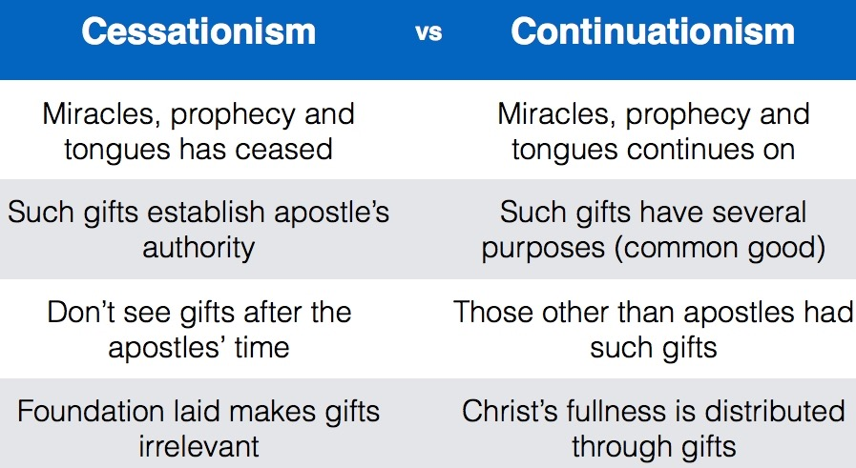
“7 But to each one is given the manifestation of the Spirit for the common good” (1 Cor 12:7).
- Christians are largely divided over Cessationism and Continuationism, two terms describing either the absence or presence of revelatory and miraculous spiritual gifts since after the apostolic age.
  - Not equal. Paul praises the gifts of the Corinthians (1:4-7) putting the burden of proof on cessationalists. Arguments are weak.
  - Greater purpose: These gifts not only affirm the authority of the apostles (Eph 2:20) as cessationalists affirm but are “the manifestation of the Spirit for the common good” (1 Cor 12:7).
  - Others possess: Stephen, not an apostle, but: “full of grace and power, was performing great wonders and signs among the people” (Acts 6:8) who along with other historical cases (John Knox) testify that miracles and revelatory gifts are not only associated with the apostles’ age.
  - Treated as typical: Paul intertwines the revelatory/miraculous gifts with other gifts accepted by all in 1 Cor 12:27-30.
- Conclusions:
1) Cessationism tends to be divisive. Rather than excluding others, we ought to work together to accomplish God’s greater purposes. We need each other to do all of God’s work in God’s way (theology: body).
2) Without suspicion, we can together utilize discernment for the protection and good of all, eliminating much excessiveness (false gospel).
3) Working together, perhaps we could see the deeper issues, seeing these revelatory/miraculous gifts more apparent in pioneering areas (apostle=missionary=sent ones). Sensible: Gifts given according to need.

C) Clarification on the Gift of Tongues (1 Cor 12:27-31)
“27 Now you are Christ’s body, and individually members of it. 28 And God has appointed in the church, first apostles, second prophets, third teachers, then miracles, then gifts of healings, helps, administrations, various kinds of tongues. 29 All are not apostles, are they? All are not prophets, are they? All are not teachers, are they? All are not workers of miracles, are they? 30 All do not have gifts of healings, do they? All do not speak with tongues, do they? All do not interpret, do they? 31 But earnestly desire the greater gifts. And I show you a still more excellent way” (1 Cor 12:27-31).
- “Miracles, then gifts of healings, helps…” (28). While Paul did not mention the miracle, prophecy and tongue gifts in Romans 12 or 1 Peter 4, but his inclusion of them in this mixed listing affirms their normalcy.
- Paul drops no hints of the uselessness of the gift of tongues from the church but includes it with other charismatic gifts in such a way that prioritizes equipping gifts over other gifts.
- “All do not have gifts of healings,…tongues,… interpretations, do they?” (30) insinuates that some have wrongly insisted on the presence of spiritual gifts, like speaking in other languages (tongues) as a sign of salvation or spirituality (28,31). Be wary! (see Lesson 9-Acts)
- Reflection: Why is there so much personal attachment and value put on speaking in tongues where most of the gifts do not lead to such extreme affection or devotion? Perhaps tongues is considered more than a spiritual gift: (1) A clear sign of the Spirit’s filling (see Acts); and (2) spiritual communication with God. Much like prayer it seems that tongues is treated as a means by which they commune with God, grow, and thrive, perhaps concluding that others are not intimate with God (1 Co 14:2?).
Summary: Every genuine believer is empowered by the Holy Spirit, receiving a spiritual gift, for God’s greater purposes of strengthening His body. If we do not prioritize God’s mission and purpose, then it is easy to be distracted with spiritual gifts rather than God’s purposes.

Discussion Questions
- How can we keep ourselves from getting prideful over our spiritual gifts?
- Are all the gifts of the Holy Spirit for this age or only for the early church? Explain.
- How should we understand and treat others who look at spiritual gifts different from us?

http://churchofthekingmcallen.org/pastors-blog/prophecies-of-john-knox/

