
Oakland International Fellowship Paul J. Bucknell

16) Special Experiences of the Spirit (1 Th 1:5)
Section 4: Christian Doctrine Handout
Two looming, ongoing problems face the church: (1) Why does the church appear so dead? and (2) Why are more Christians not filled with God’s Spirit (also Rev 2-3)? Because of these questions, many suggestions are put forward, desiring for God’s love and truth to have a bigger impact on the church. Instead of despising theology or the church, let us strengthen our faith by a firmer grip on the Holy Spirit’s life-changing work in the church.

A) The Need for the Spirit’s Work (1 Th 1:5)
“That He would grant you, according to the riches of His glory, to be strengthened with power through His Spirit in the inner man” (Eph 3:16).
- “According to the riches of His glory” helps us imagine the celebrated work that God is doing in us.
- “With power through His Spirit” restates the assurance that God’s people can overcome the world.
- “Inner man” teaches that much of the Spirit’s work has to do with our new spiritual being.
“For our gospel did not come to you in word only, but also in power and in the Holy Spirit and with full conviction; just as you know what kind of men we proved to be among you for your sake” (1Th 1:5).
- “For our gospel” mentions the preached word, but also the Holy Spirit’s power and conviction (Ac 2).
- We are right to demand the church to powerfully live out the love and truth of the gospel.

Important Questions:
- _____ Does the Holy Spirit come to stay with every genuine believer?
- _____ Will the Holy Spirit always fully manifest Himself by filling us?
- _____ Should the believer seek a second blessing of the Spirit to fully live out the gospel
(e.g. laying on of hands, slain in Spirit, etc.)?
- _____ Doesn’t the Spirit desire to fully show His power, presence, love, and wisdom?
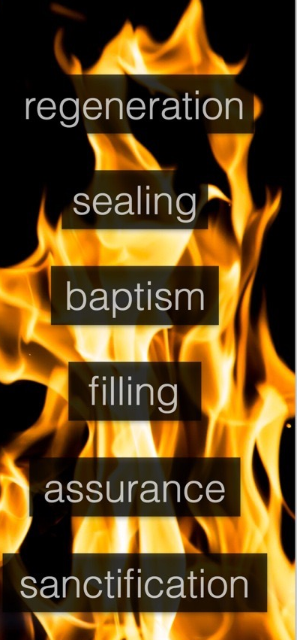
Summary: What we genuinely believe about the Holy Spirit greatly shapes our pursuit of Him in our lives. What do you believe? How important is it to you?

B) Describing the Biblical Terms for the Spirit’s Work
By carefully defining the biblical terms associated with the Spirit’s work, we avoid much confusion and are able to concisely grasp the Holy Spirit’s work as it relates to our lives.
- Regeneration (Tit 3:5; Jo 3:7 ‘born again’) is the one-time spiritual life-giving operation by the Holy Spirit that animates His people by God’s presence and power.
- Sealing of the Spirit (2 Cor 1:22; Eph 1:13) refers to the one-time spiritual marking of a believer at salvation forever establishing him or her as His own.
- Baptism of the Spirit (Lu 3:16; Ac 1:5,2:38,10:47) is the unsought for, obviously noticeable work of God in a believer’s life, that flows from regeneration.
- Filling of the Spirit (Eph 5:18) reminds us of the ongoing responsibility for each believer to be fully influenced by the Spirit’s presence and work in their daily lives.
- Assurance of the Spirit (Ro 8:16) speaks of the special revelation of the Spirit, persuading God’s people that they belong to Him forever.
- Sanctification of the Spirit (2 Th 2:13; 1 Pe 1:2,15-16–holiness) refers to the experiential process of increasingly being shaped in life and character by the Spirit to be holy like God.
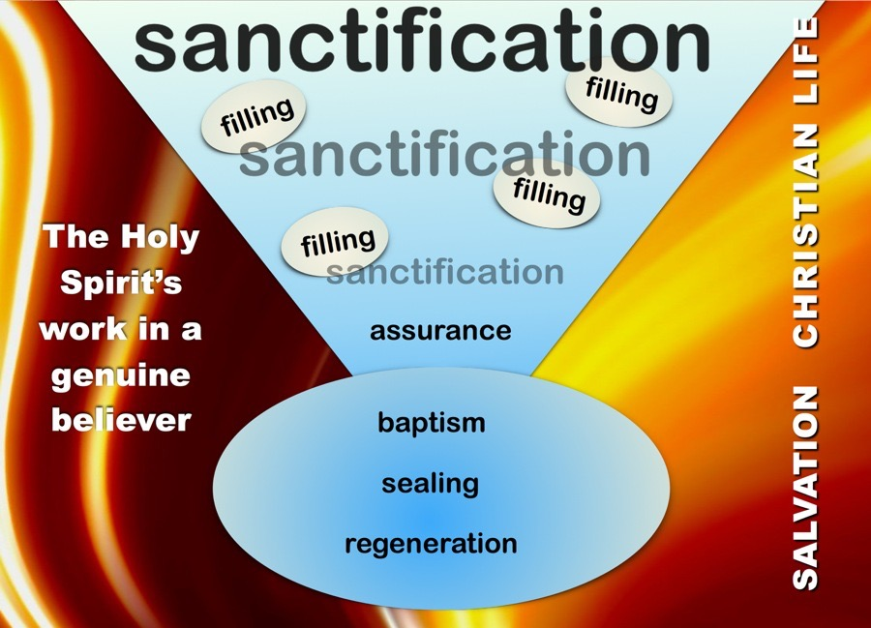
Summary: A proper ability to rightly describe the Spirit’s work in believers’ lives enables God’s people to concisely and carefully understand key experiences.

C) Describing the Special Blessings (John 15:7-8)
“If you then, being evil, know how to give good gifts to your children, how much more shall your heavenly Father give the Holy Spirit to those who ask Him?” (Lu 11:13)
- “Give the Holy Spirit” indicates the powerful experiential presence of the Spirit of God upon His people.
- “Your heavenly Father” shows (caution: pre-cross) that this was not for salvation but apparently other experiences of the Spirit’s work in their lives. Some professors of faith ought to wonder if they have life at all!
- “To those who ask Him” teaches us that His gifts are personal, requested, and unique. Further intimacy with God is always to be sought within the biblical parameters of love, forgiveness, obedience, and humility.
“If you abide in Me, and My words abide in you, ask whatever you wish, and it shall be done for you. By this is My Father glorified, that you bear much fruit, and so prove to be My disciples” (John 15:7-8).
- Although special experiences can come, they are set in an abiding relationship with Christ constrained by God’s Word. Focus on abiding rather than ‘laying on of hands’ (Ac 8:18-19) or unbiblical ‘being slain”.
“Seek not an experience, but seek Him (Christ). Seek to know Him. Seek to realize His presence. Seek to love Him. Seek to die to yourself and everything else that you may live entirely in Him and for Him and give yourself entirely too. If He is at the center, you will be safe. But if you are simply seeking an experience, …thrills…excitement, well then you are opening the door to the counterfeit and probably receive it.” [Martyn Lloyd-Jones T:34:11-34:48].
John Flavel
[T:19:35-22:10]
Jonathan Edwards [T:22:16-24:34]
D.L. Moody [24:35-27:10]
Summary: Two important conclusions must drive our perspectives: (1) Believers do not need another or new experience of God’s Spirit to be filled with and otherwise led by the Spirit of God; and (2) many believers have been specially moved of God by special experiences of the Spirit, often heightening the believers’ sensitivity to the things of God, enabling their service of ministry to be more productive and ongoing (John 15:1-15).

D) Seeking Revival
Revival is the outpouring of God’s Spirit upon the believers in such a way as to significantly move the work of God forward in their lives and that many come to know the Lord.
“The town,” says Mr. Edwards, “was never so full of love, nor so full of joy, nor yet so full of distress, as it was then.” Whenever he met the people in the sanctuary, he not only saw the house crowded, but every hearer earnest to receive the truth of God, and often the whole assembly dissolved in tears: some weeping for sorrow, others for joy, and others from compassion. In the months of March and April, when the work of God was carried on with the greatest power, he supposes the number, apparently of genuine conversions, to have been at least four a day, or nearly thirty a week, take one week with another, for five or six weeks together.”
=> Seek revival not only for yourself but for those around you, that God’s glory might be further displayed in the places that darkness now appear to rule.

Conclusion
God’s people are the temple of God, and when filled with His Spirit will eagerly seek obedience to the Word (there are always counterfeits). The biggest questions arise when we speak about joy in the Lord but do not have the joy. We speak of God’s love, but do not exercise that love. We teach God’s holiness, but inwardly despise His holiness by preserving secret places for our sins and doubts of His will.

Discussion Questions
- Do you sense that the church is missing something? Explain.
- How do you discern between the genuine and bogus work of the Spirit of God in the lives of His people?
- Do you sense a need for a revival for the church today? Why? What would you want to happen?

http://www.mljtrust.org/search/?q=further+reflections
Narrative of Surprising Conversions. A Treatise Concerning Religious Affections.
CHAPTER VII. Remarkable revival of religion, in 1734, and 1735 by Jonathan Edwards (Vol 1 of The Works of Jonathan Edwards).

